DE_Quaint
Document Date: 21/01/2019
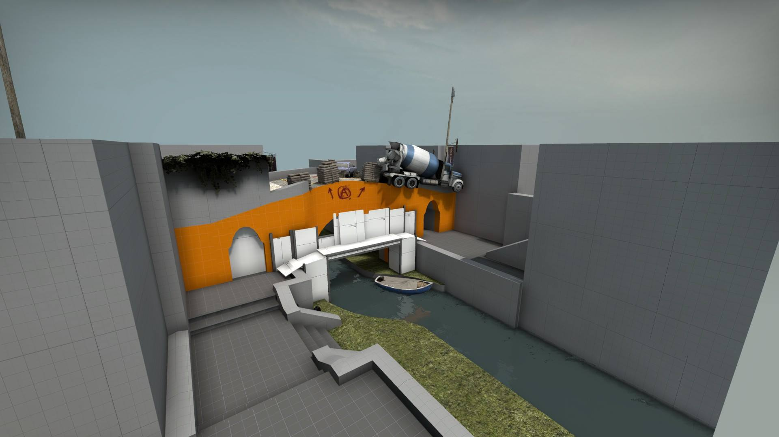

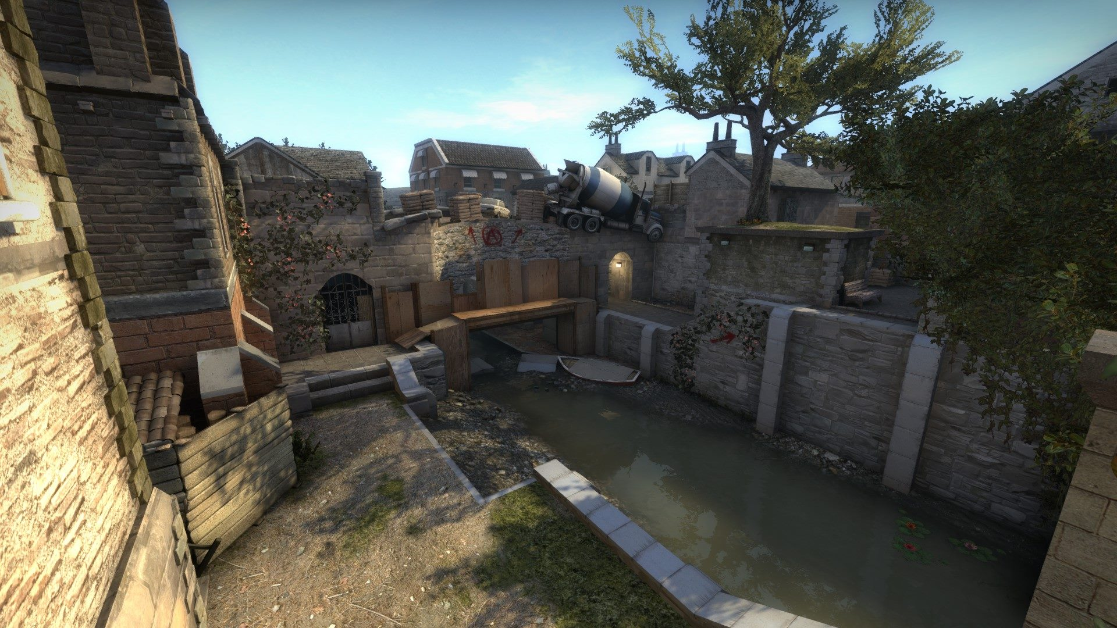

Design & Art: Ben Wheatley

Table of Contents

Introduction 3
Map Summary 3
Location in Story 3
Environment Type 3
Time of Day 3
What Makes This Location Unique? 3
Technical Overview 4
Map Metrics 4
Map Objectives 4
Challenge Highlights 4
Map Design 5
Map Scale 5
Lower Level Layout 6
Upper Level Layout 6
Cover Layout Lower Level 7
Cover Layout Upper Level 7
Bridge Height Example 8
Location Callouts 9
Map Gameplay 10
Map Encounter Points 10
Encounter Points Breakdown CT Side 11
1. CT Stairs 11
2. CT Long 15
3. CT Bridge 18
Encounter Points Breakdown T Side 20
4. T Long 20
5. T Bridge 23
6. T Lower 25
Bombsite Design 29
Plant Positions 29
Post Plant Positions 30
Map Detailing 32
Landmarks 32
Colour Language 36
Leading Lines and Breadcrumbs 40
Pinching 42

Introduction
In this document I have detailed the design behind the final version of my CSGO wingman map DE_Quaint. It was created over an 18-week period, starting development on August 7th and continued as my Final Year Project during my first semester of my third year at university.
I wanted to meet a deadline of December 16th as that was when the entry to the R/CSMapMakers competition ended. This competition lined up perfectly with my semester and offered a unique chance to gain review from both my University and esteemed members of the Counter Strike level design community. This also meant I could see how my map compared to competition outside of university.

Map Summary
When a bridge in this unnamed UK village is damaged, the canal is drained to allow re-construction. Before the SAS can arrive to investigate a possible terrorist threat. The Professionals arrive on the scene to finish the job!
Can the SAS stop them from destroying the bridge and protect the rustic atmosphere?

Location in Story

Environment Type
Quaint is set on the outskirts of a small British village. The contrast of countryside to a more developed rural area can offer great visual disparity for each side of the map. T areas are more run down, acting as visual contrast but also a narrative element that explains how they were able to enter the area in the first place.

Time of Day
The map is set on a sunny summer day at early morning to mid-day. This allows for longer stretching shadows while also having the maps darker areas illuminated by brighter light bouncing off the adjacent walls and reflecting in the water of the canal.

What Makes This Location Unique?
Most Counter Strike Global Offensive maps are set throughout different locations in the world. One of the locations not covered in official or as often in community maps is the UK. Being a resident, I felt it would be a great opportunity to create a level that has a unique location while utilising reference images to achieve an authentic rustic look.
By the end of the project I had to cut out certain elements such as custom textures and assets that I would have liked to add, however I believe that my heavy use of reference and theming with sells the location as being in the UK.

Technical Overview

Map Metrics
- East Midlands - UK
- SAS -vs- The Professionals
- 3pm – July. 26th – 2018
- Sunny skies and hot weather
- Visibility – 2500 units
- Overall Map Scale: Vertically: 4450 units
Horizontally: 4592 units
- Playable Map Scale: Vertically: 2560 units
Horizontally: 2560 units
- Longest sight line in the map is 2300 units

Map Objectives
Game mode – Defuse, Wingman variant.
The terrorist team has to plant the bomb on the bombsite and have it explode or eliminate the enemy team.
The counter terrorist team must defend the bombsite from the attackers, defusing the bomb if planted. They also win the round if they eliminate the enemy team before this happens.
The wingman variant changes this game mode from the standard 5v5 with 2 bombsites, to a 2v2 with only 1 bombsite.

Challenge Highlights

- As Terrorists:
Battle to gain a foothold on the bridge from the lower elevation.
Use one of the two flanking routes to gain an advantage on the defending team.
Plant the bomb and then defend from post plant positions.
Watch for aggressive CT pushes both over and under the bridge.
Taking the bridge head on results in players challenging strong CT positions.

- As Counter Terrorists:
Hold both flanking routes and the bridge with only 2 players.
Gain a read on where the terrorists plan to attack from and react accordingly.
Cover the bombsite and prevent a plant as retaking can be very challenging.
Push aggressively to gain information about terrorist positioning.
Maintain a foothold on the bridge as losing pressure on the top side of the map can easily result in a lost round.

Map Design

Map Scale
Each cell on the overview is 512 x 512 units.
A group of 4 cells are 1024 x 1024 units.
The grid is accurate as it was created in the editor, compiled then screenshot as a radar overview to be used in photoshop.

Lower Level Layout
This simplified layout shows the height changes of the lower level.
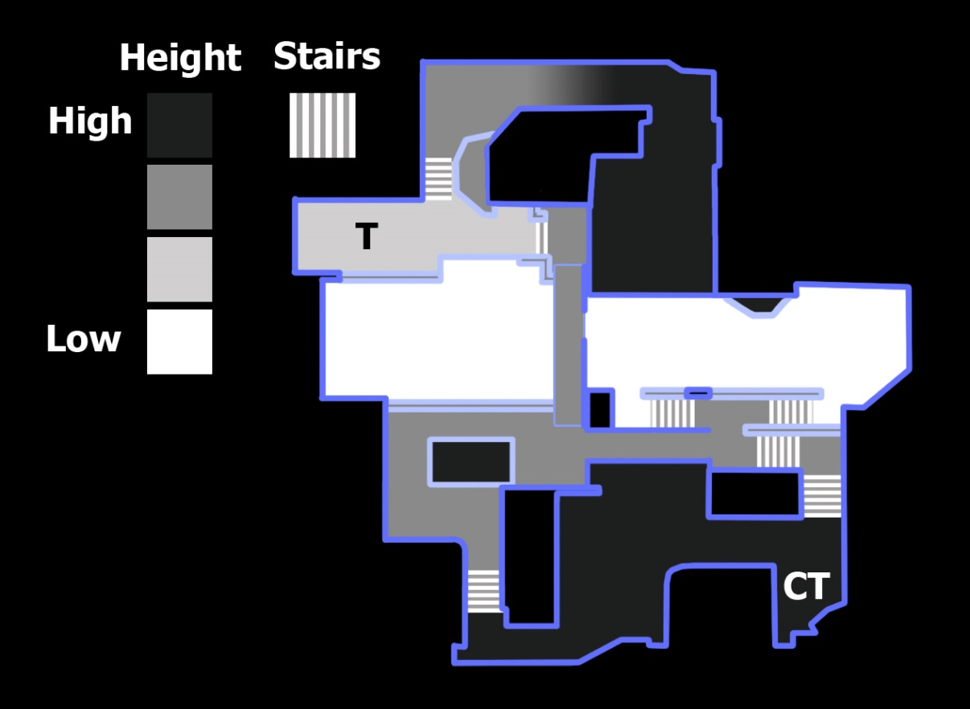

Upper Level Layout
This simplified layout shows the height changes of the upper level.
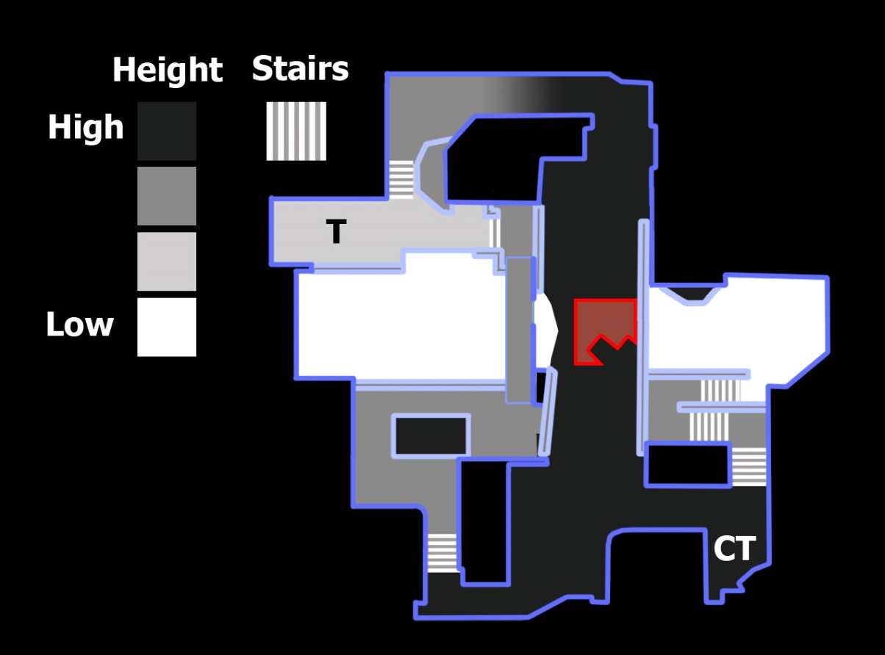

Cover Layout Lower Level
The layout can now be seen with all the cover applied. The same key can still be applied for the height of the level.
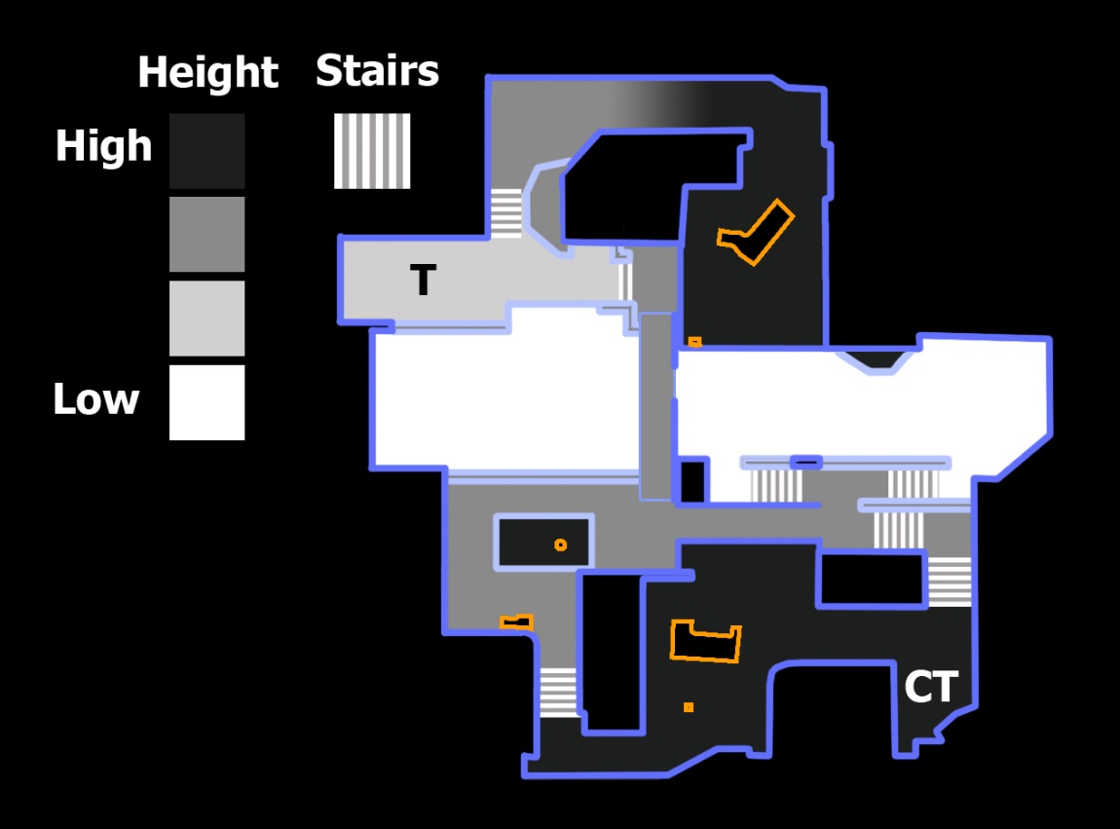

Cover Layout Upper Level
As you can see from the diagrams, I used most of the cover on the top of the bridge by the bombsite. The height of the bridge also acts as cover as the curve of the bridge is the same height as a player, breaking up each side of the bridge into two separate areas.
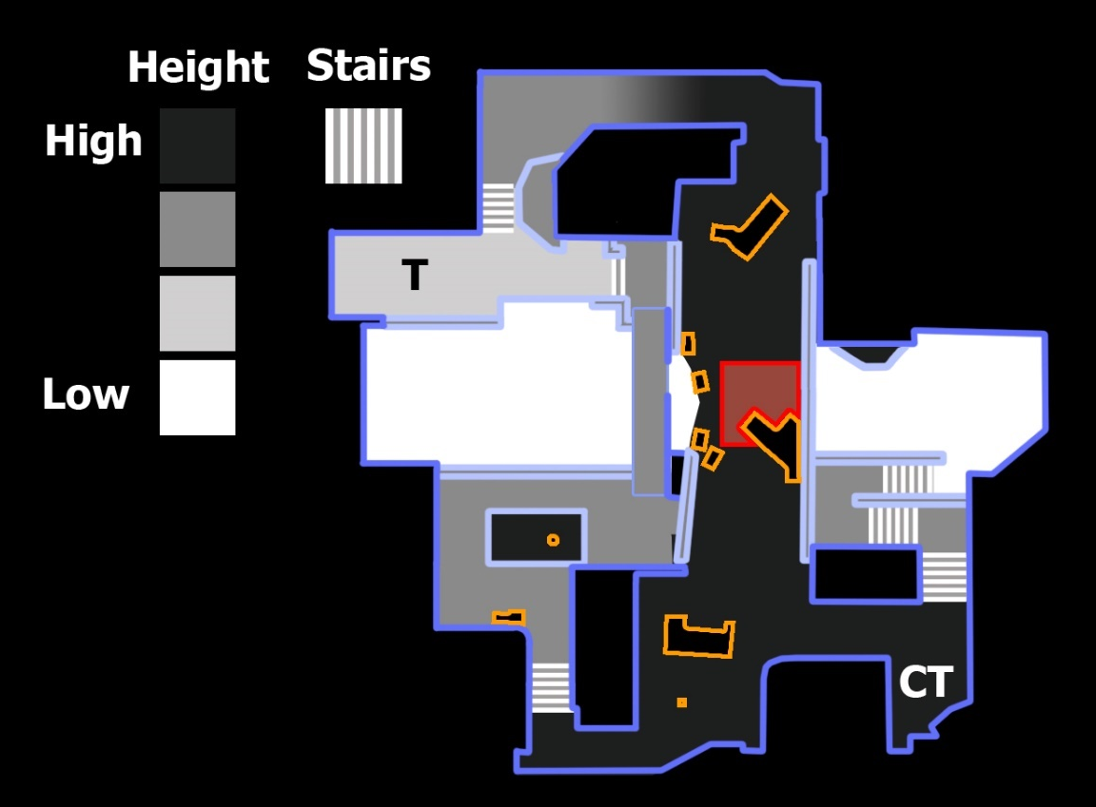

Bridge Height Example
As you can see from the images below, when the bridge is removed you can see that the players on the other side of the bridge are at the same height as you. But once the bridge is added back in the height helps break up sight lines.
Bridge removed example.
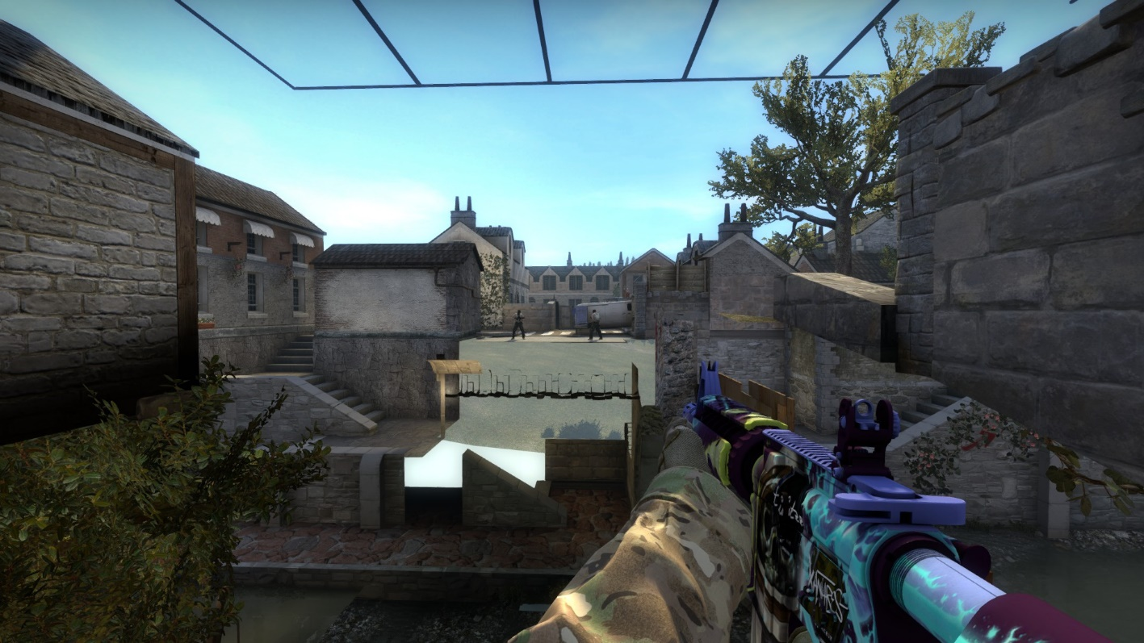
Bridge as found in the map example.
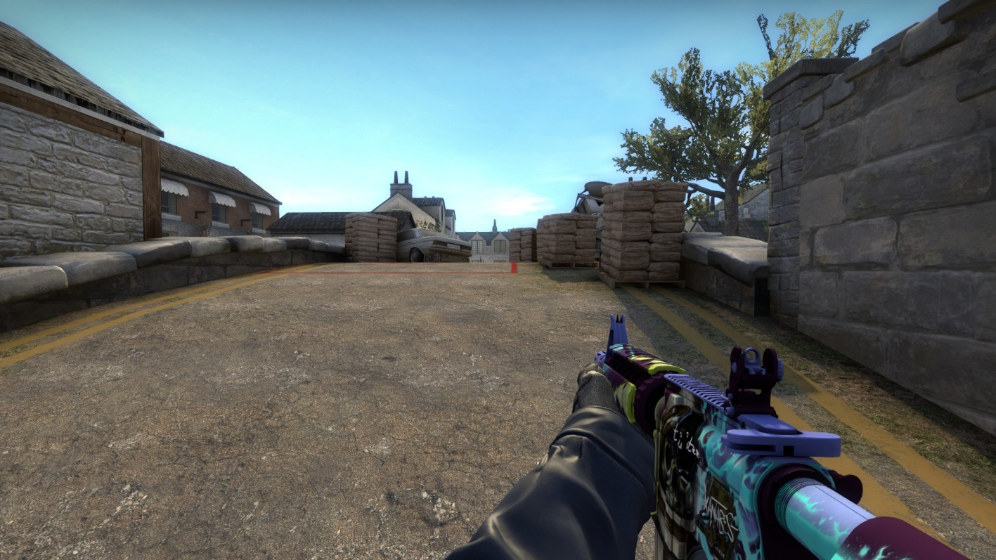

Location Callouts
The location names were chosen to denote which team controlled which area. In an actual play environment, the names are chosen by the players for the most part. To accommodate this, I tried to make each area feel unique, there is a clear visual difference between CT long and T Long for example.

Map Gameplay

Map Encounter Points
There are six main encounter points within the map. Routes where players would encounter enemies but only through further aggressive play have not been highlighted to remove visual confusion. These strategies and timings are further detailed in the breakdowns on the next few pages.
As the map is a 2v2, having three lanes for players to contest is the standard. With only two defenders to watch three routes, gameplay can sometimes feel overwhelming on the default maps. My level helps to elevate the issue by having the information about where the terrorists are attacking from be easily conveyed early on through riskier positioning.
Not all is lost for T side however. They are given multiple positions and chokepoints they can smoke to deny visibility and thus any information to the CT side. This forces more reckless play from the CTs. If the CTs remain too passive, then they give up map control to the terrorist team and risk being flanked from their own fortified positions.

Encounter Points Breakdown CT Side

1. CT Stairs
Time take to reach: 3 seconds
Possible enemy threats: 2
The CT player must be careful of a push from T lower, or a terrorist trying to cross over the Scaffolding position.
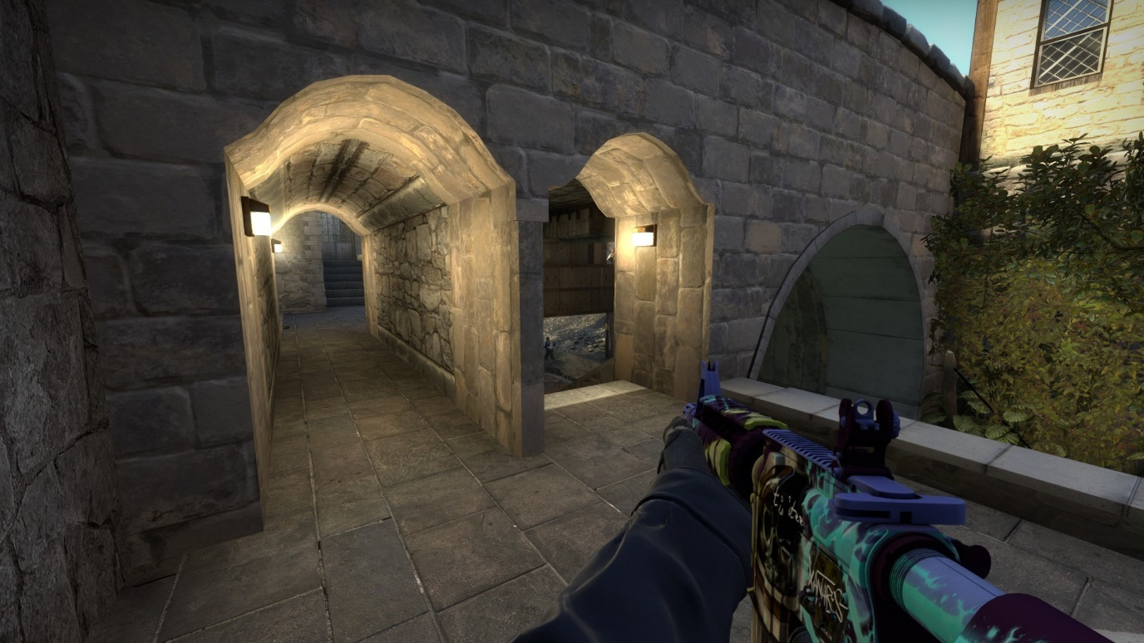
Offensive options available: 2
They can either choose to fight the enemies as they encounter them here.
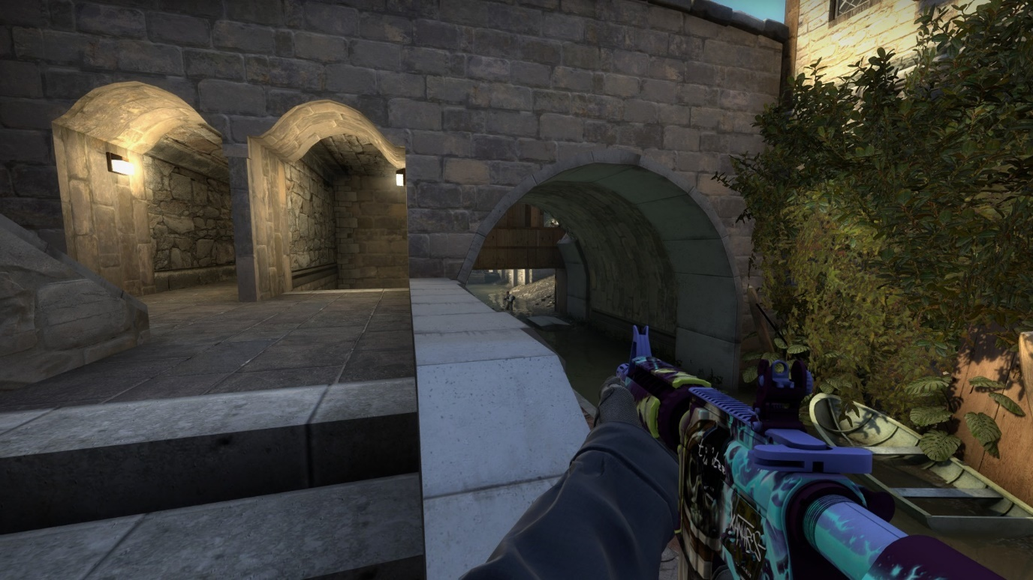
Or they can keep pushing and flash their way into the T lower area of the map. A risky play that can backfire easily. However, it places the Counter Terrorist right next to Terrorists trying to cross the scaffolding.
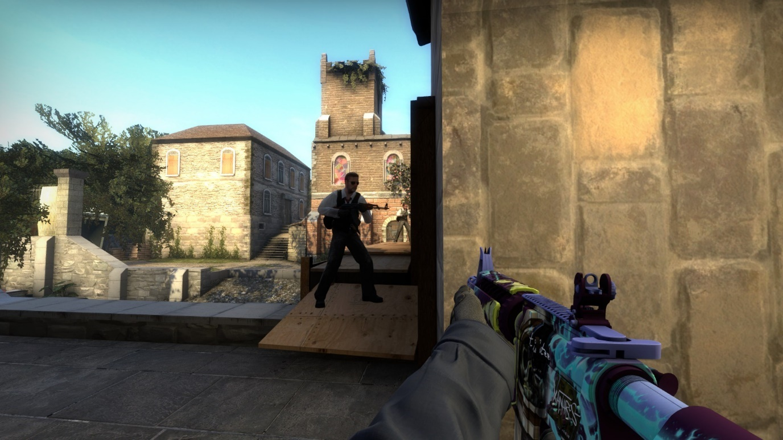

Defensive options available: 3
If they are fast enough the CT can make it to the wooden cover at CT lower. This is a very dangerous position as the thin wood is easily shot through. This lower position acts as an off angle to catch any over aggressive Ts by surprise.
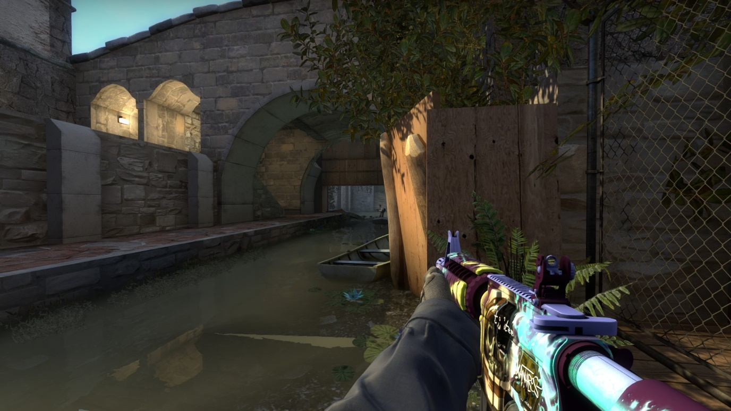
The CT player can hold back on the stairs, gaining the advantage on the lower push but sacrificing the pressure on the scaffolding push. This is a safer option but without this information they open themselves up to a CT long push or a T bridge approach.
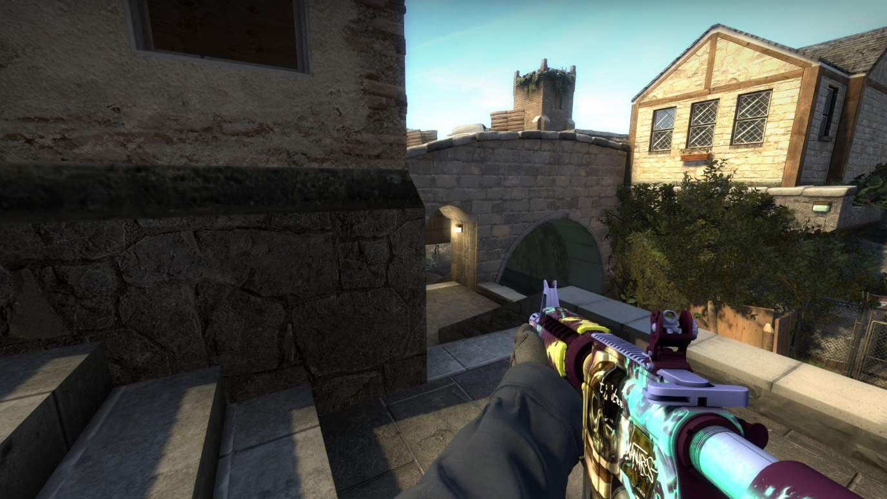

Alternatively, the CT player can give up lower entirely, smoking the staircase if they suspect a rush.
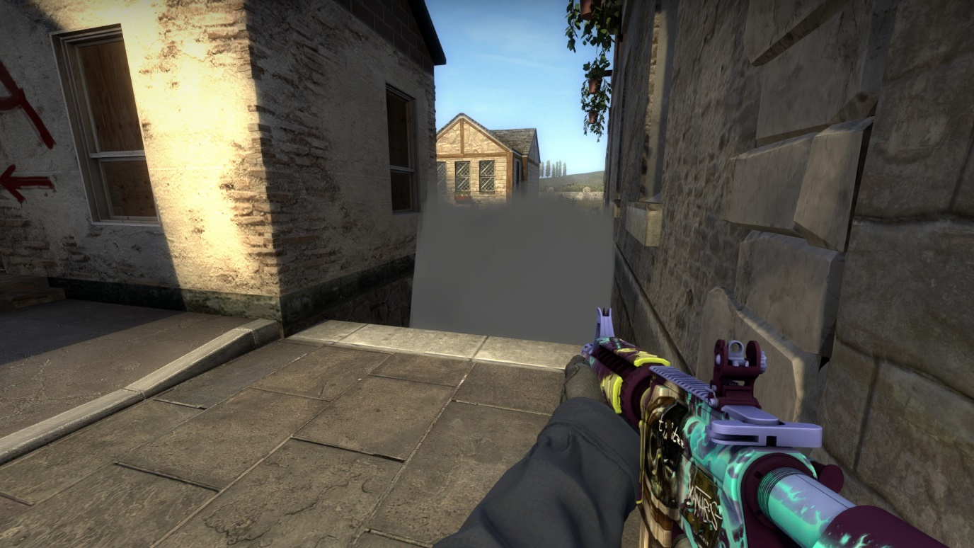
This allows them to take the high ground on the bridge. However, this does expose themselves to multiple other angles in the progress.
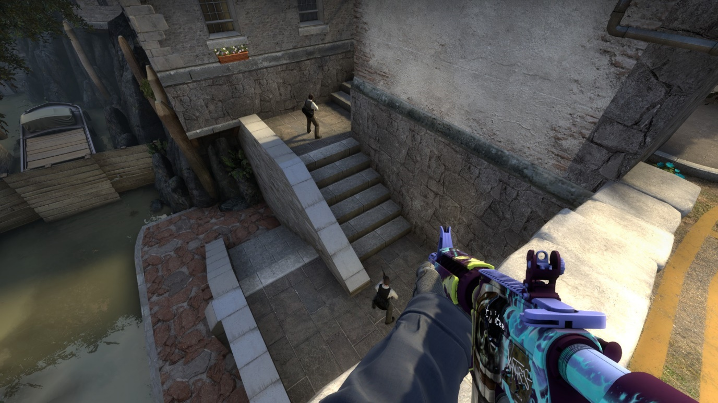

2. CT Long
Time taken to reach: 8 seconds
Possible enemy threats: 1
The CT player can spot the T through a tight diagonal angle, if they want a clearer view then the CT has to push further down the choke point.
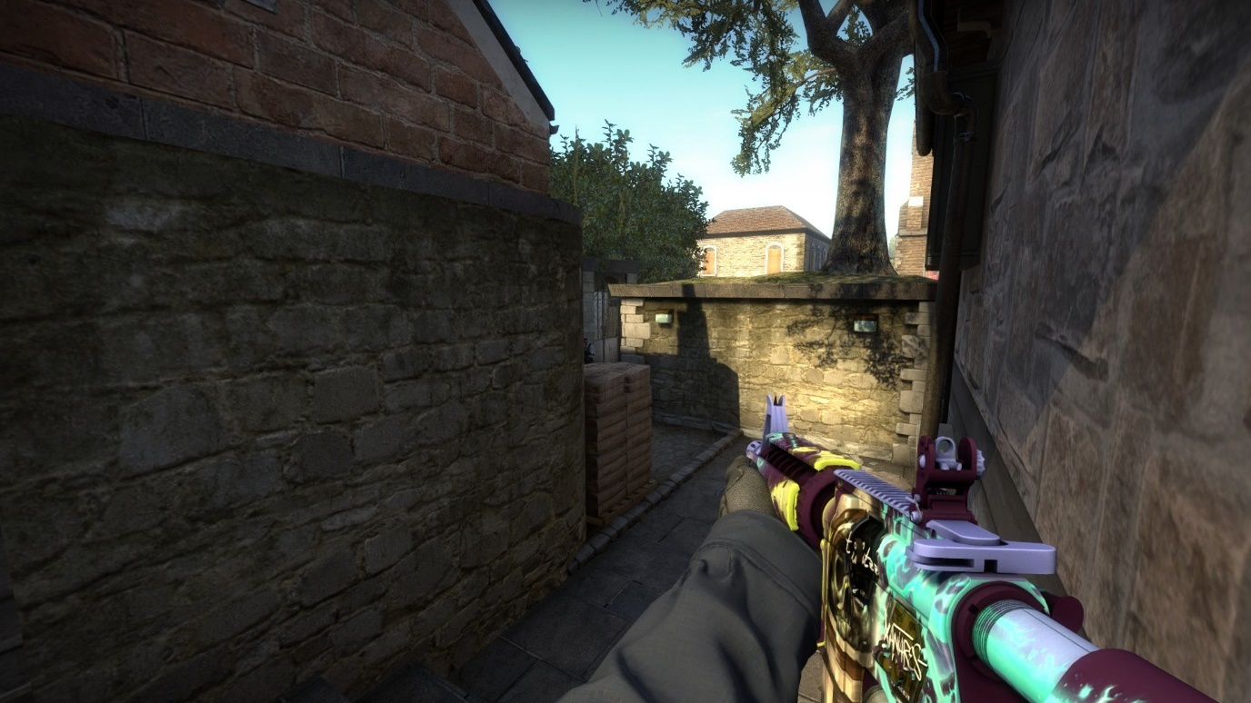
Offensive options available: 2
They can either challenge the potentially two terrorists at this position which can become difficult due to the varying height of cover provided for the terrorist side.
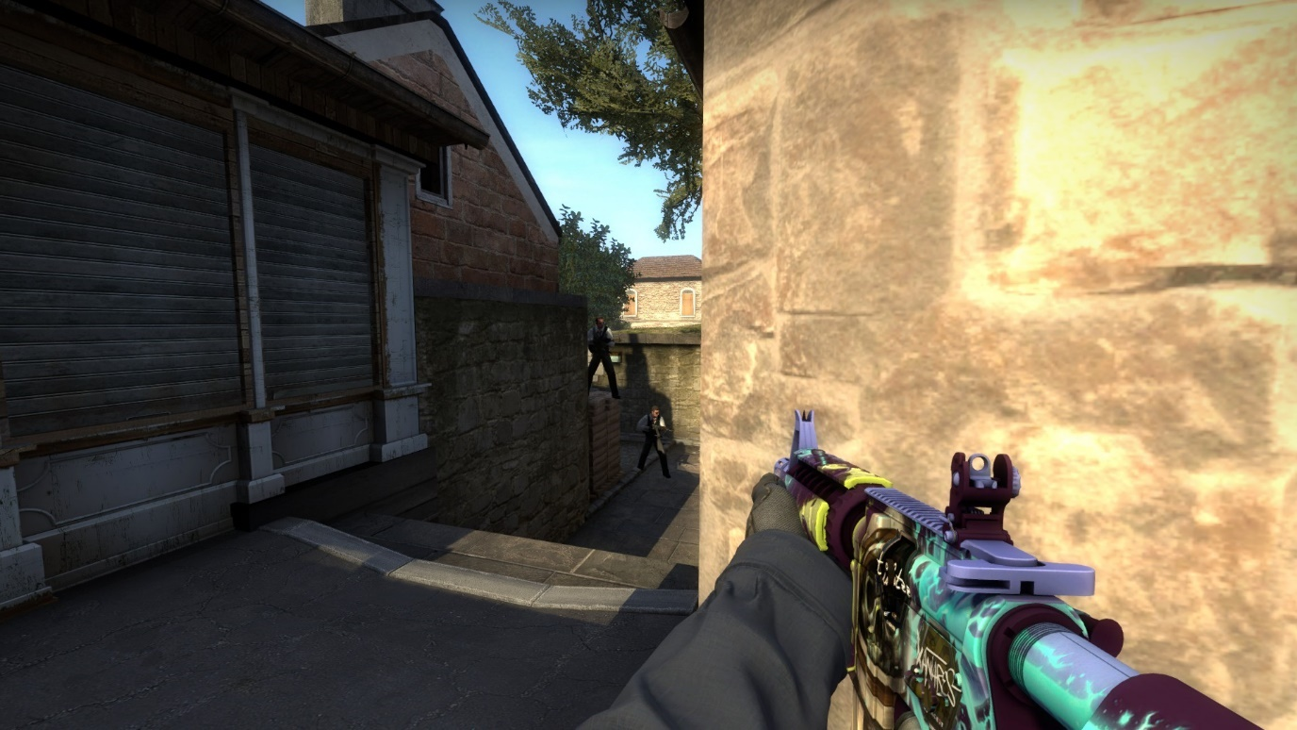
Or, if there are no terrorists present / the CT player has fought them back. They can perform a skill jump to get onto the Tree position. This gives the CT a powerful position overlooking T spawn, an angle on the T bridge approach.
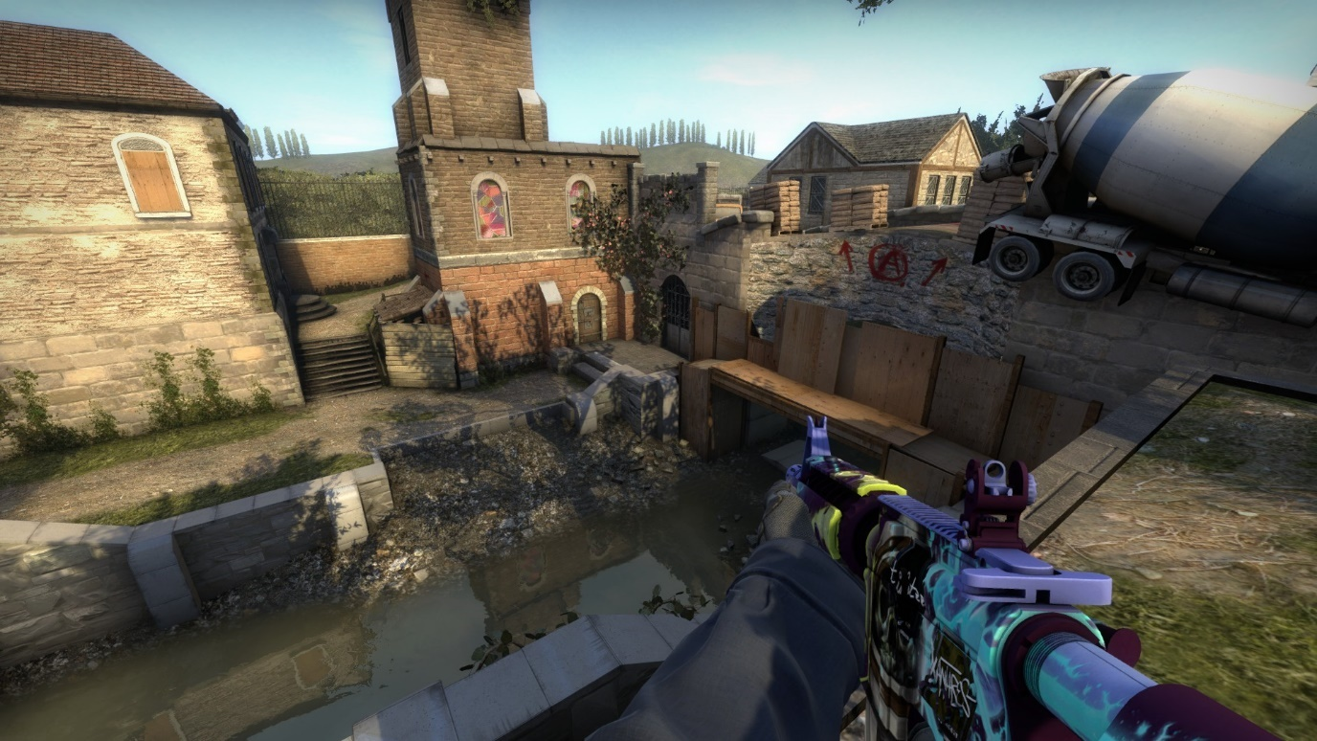
And a view towards CT spawn past the cement mixer.
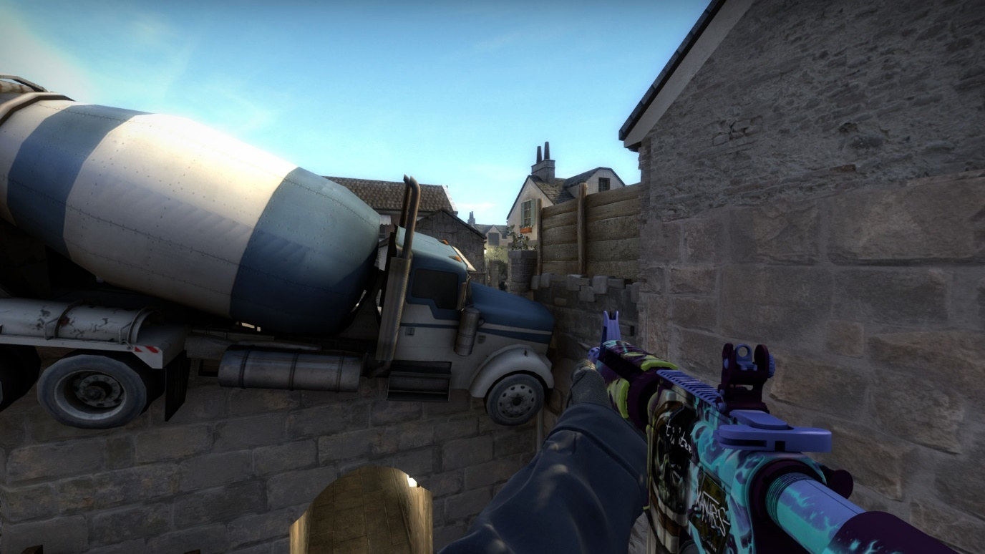

Defensive options available: 2
The main strategy would be to smoke the choke point as they see the enemies trying to aggress. They then must watch the smoke but can do so either from the Cubby position or further back on the CT bridge.
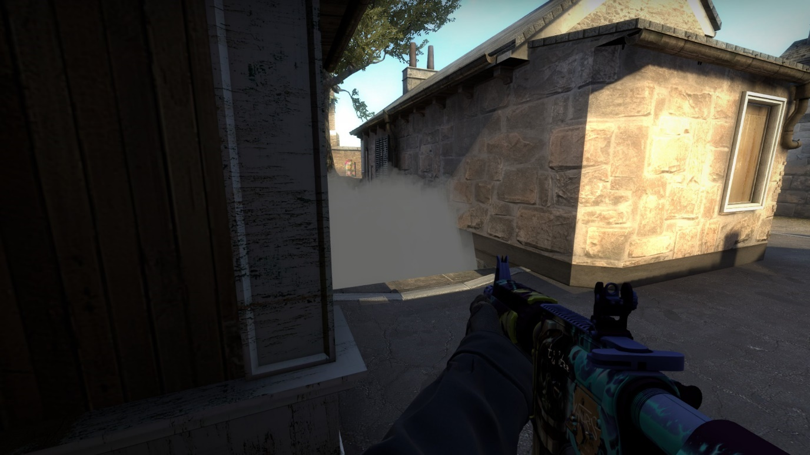
Cubby must be checked when pushing up to ensure a CT isn’t hiding there which can lead to a Terrorist with their back turned if played correctly.
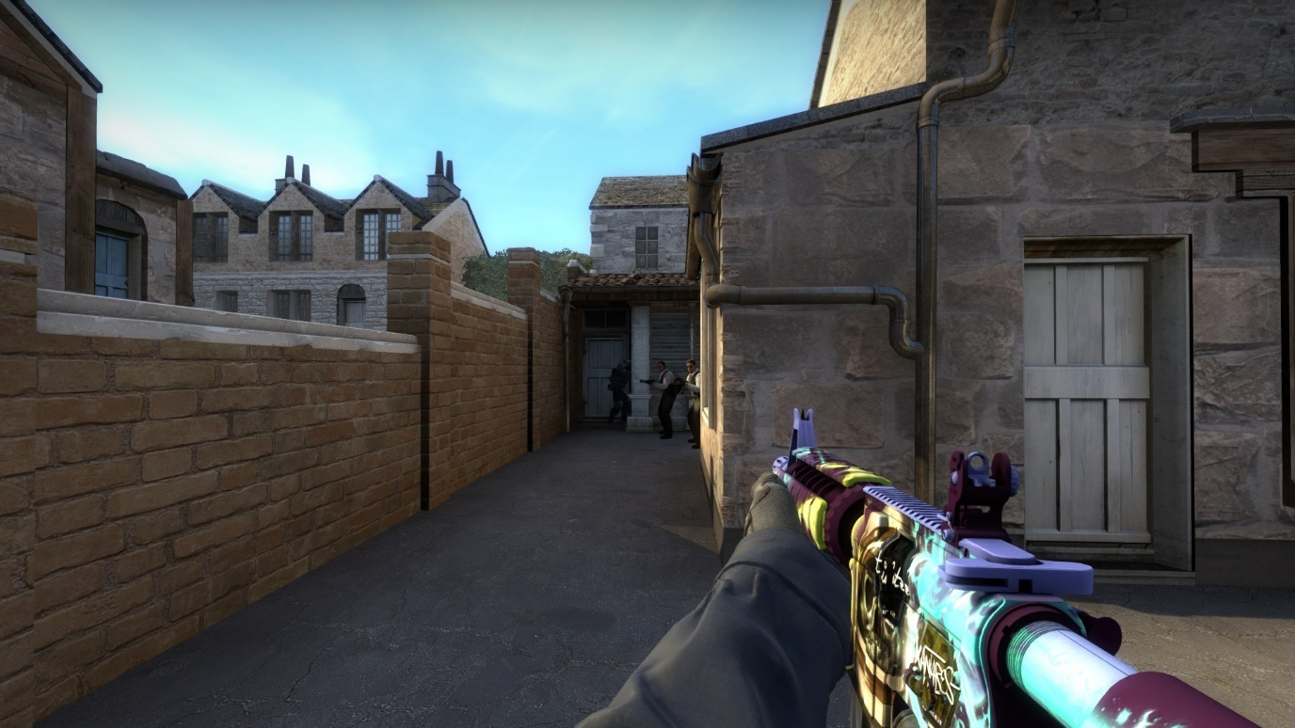

3. CT Bridge
Time taken to reach: 8 seconds
Possible enemy threats: 3
The threats come from the same direction but appear at different heights. They can peak from either side of the truck or climb over it.
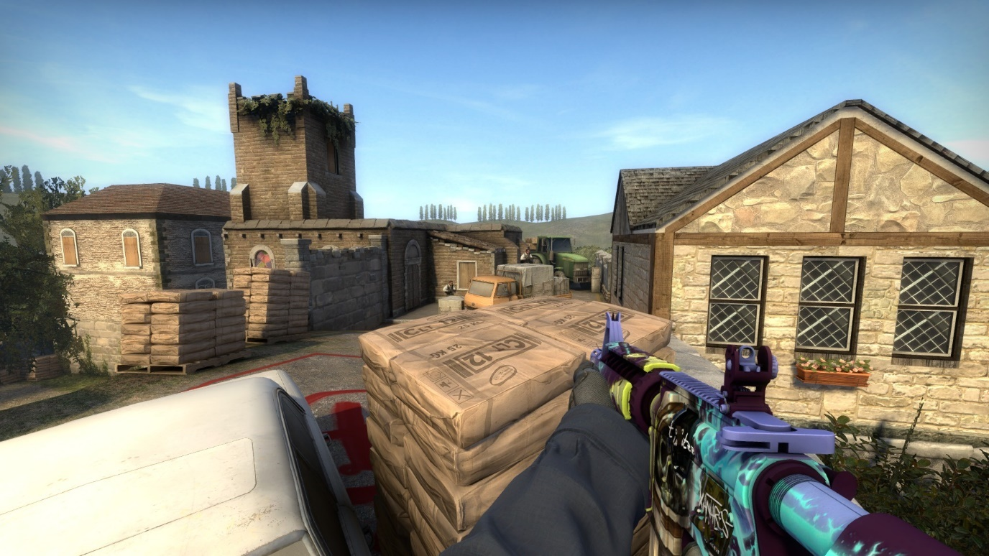
Offensive options available: 2
If no terrorists push forward to contest, a CT is then able to take the high ground on the broken side of the bridge. This exposes them to multiple angles but can be utilised along with a lower push to force a fight early on.
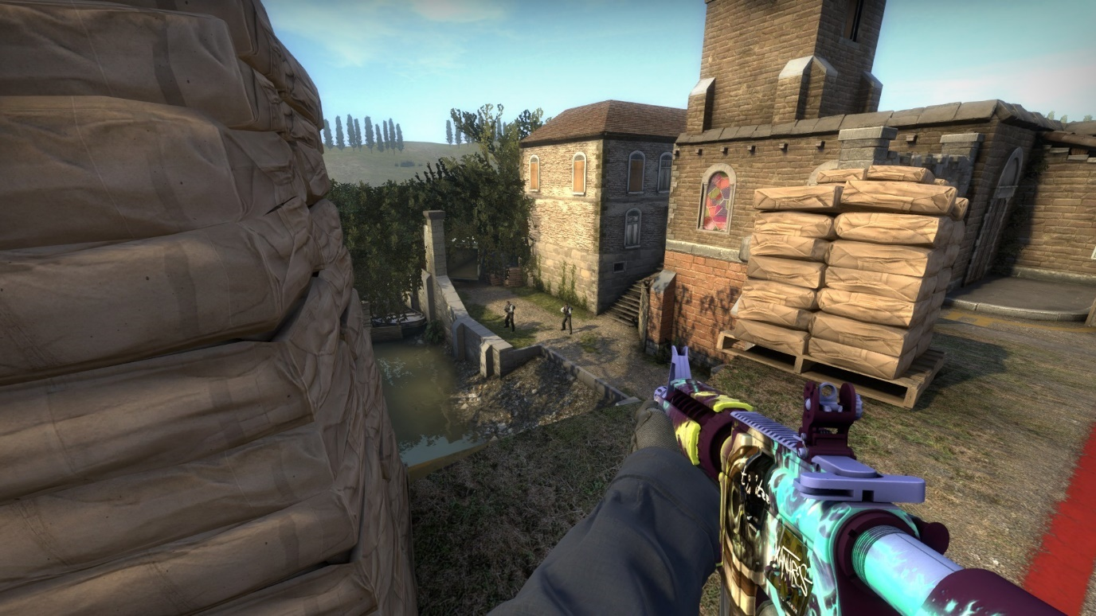
Alternatively, the CT can push through the T side of the bridge and control T long. When they do this the map essentially flips with the Ts attacking the bombsite from the CT side of the map.
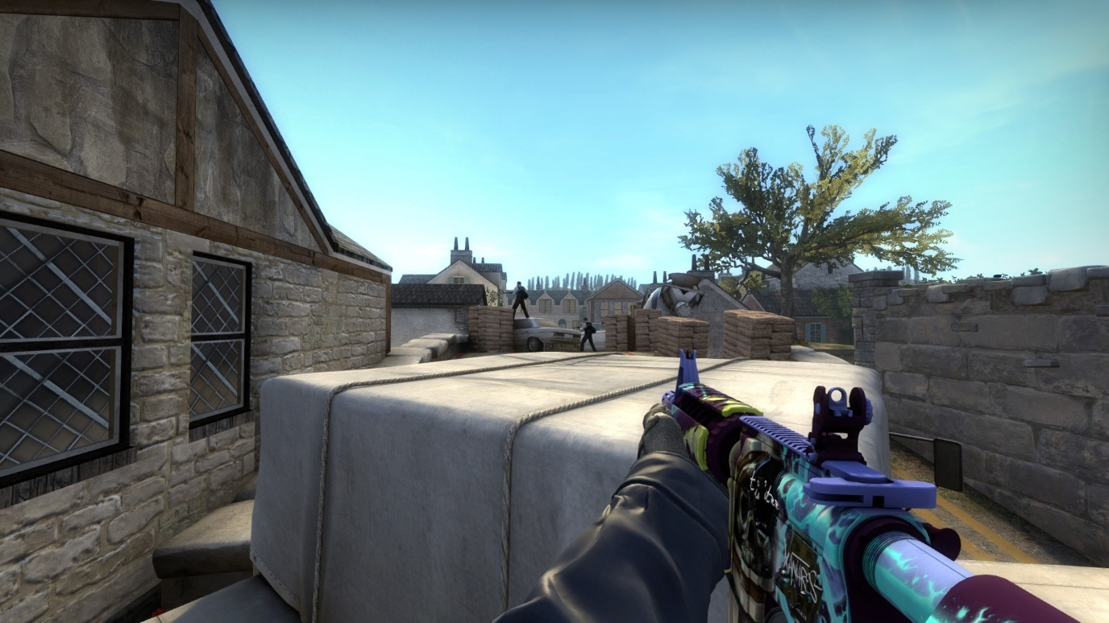
Defensive options available: 2
The CT can choose to defend from their position on the bombsite, or they can hold a safer position further back but then lose sight of the left side of the truck push. Potentially allowing Terrorists to sneak up and get onto the bombsite unseen.
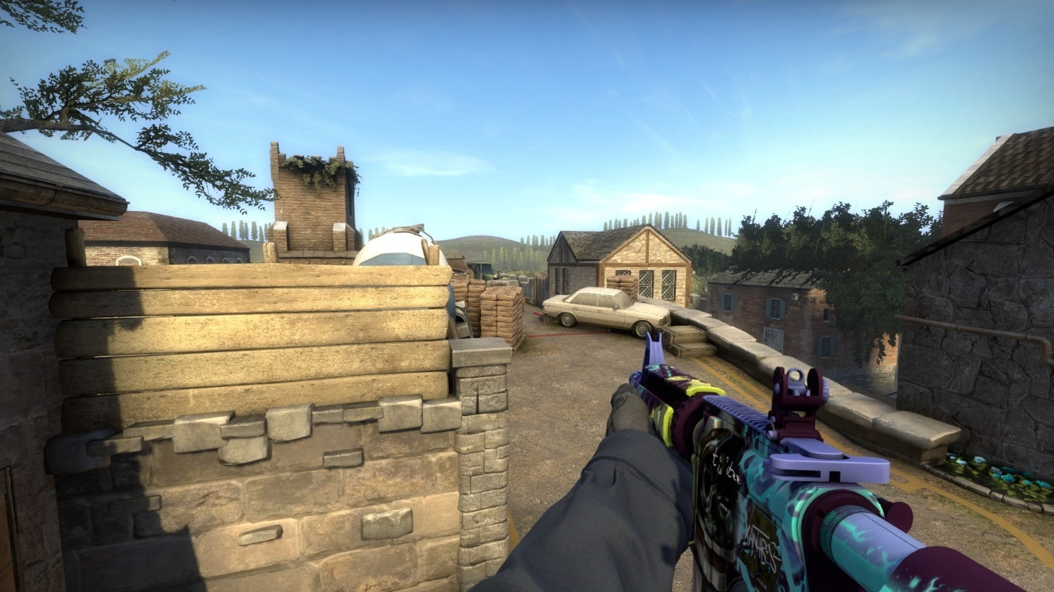

Encounter Points Breakdown T Side

4. T Long
Time taken to reach: 8 seconds
Possible enemy threats: 1
The CT can only see the T through a small angle unless they push up and expose themselves.
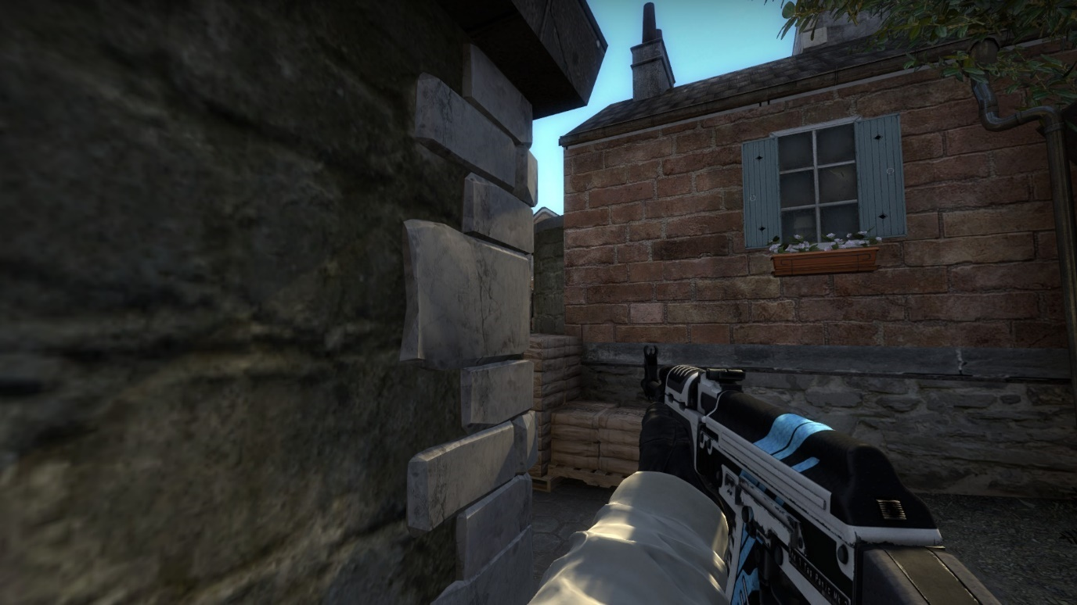
Offensive options available: 3
The Ts can peek the corner at regular height.
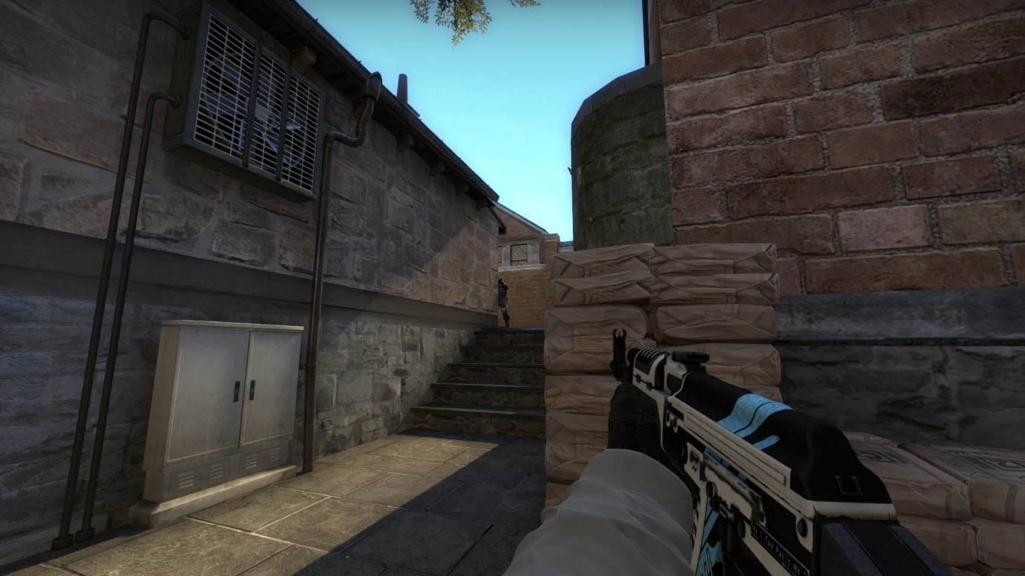
Or they can use the sandbags to peek at a higher elevation.
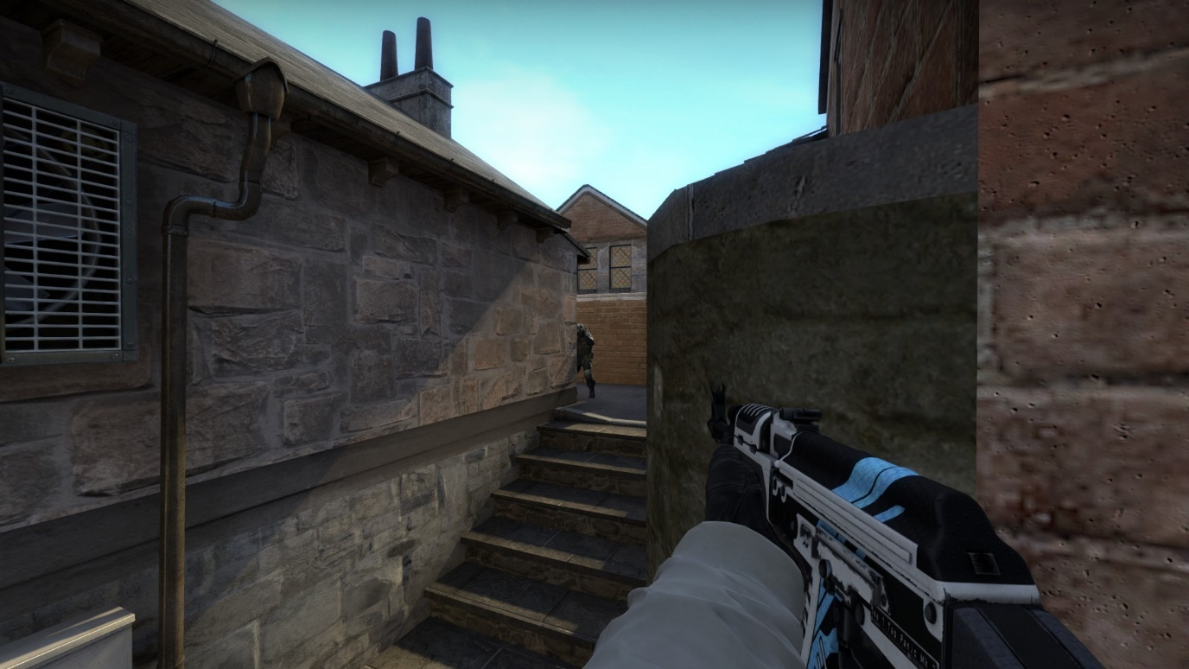
If the chokepoint is smoked off the Ts can boost onto tree to try and see over the smoke. This also gives them a view into CT spawn to catch any rotating CTs off guard.
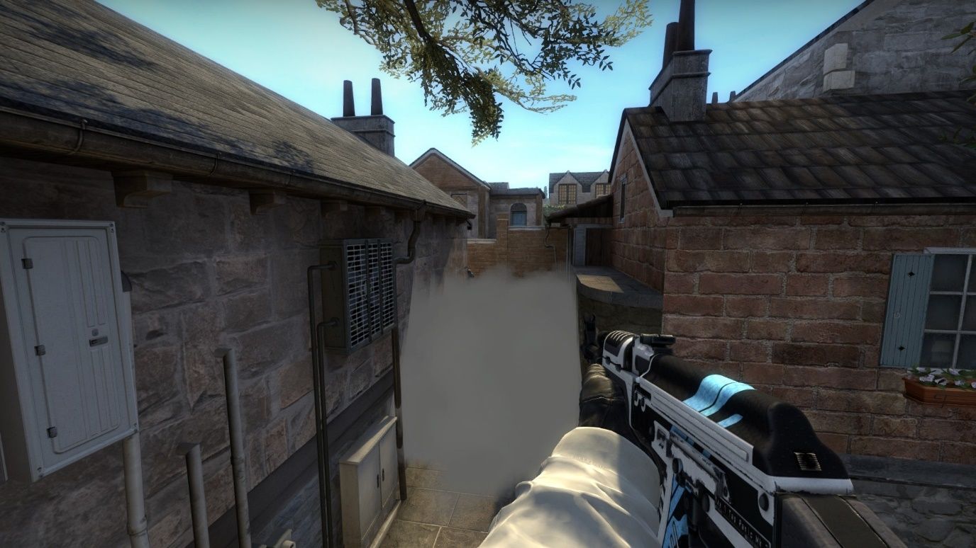

Defensive options available: 2
The tree boost can also be a defensive option as it allows players to watch for any spawn pushes while maintaining a view of the bridge to be weary of any aggressive CT peaks.
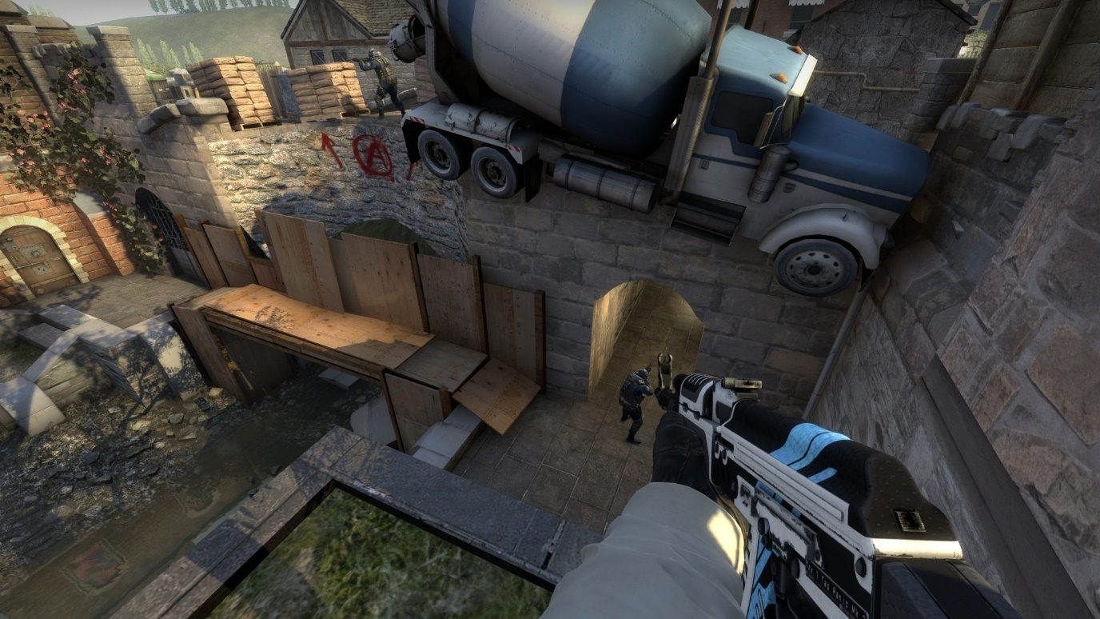
If the long assault fails they can still fall back to T lower, however at this point T long might already have been taken so its best to feel out CT stairs as an option.
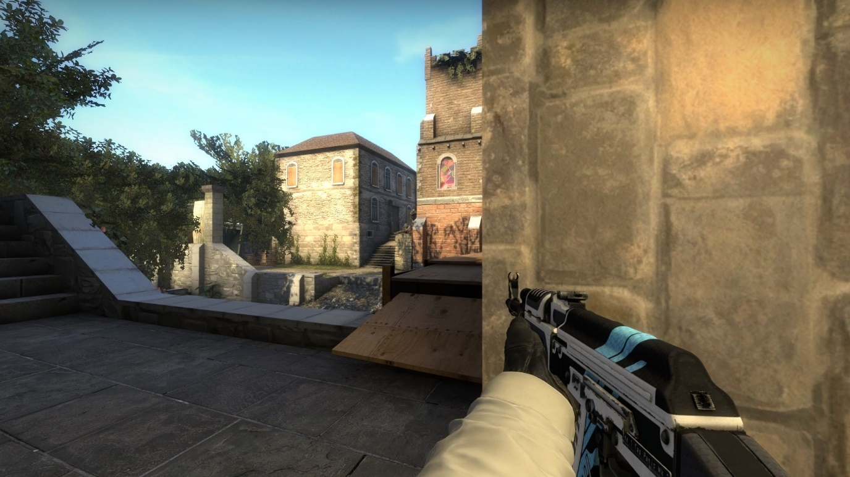

5. T Bridge
Time taken to reach: 8 seconds
Possible enemy threats: 3
CTs have a similar amount of positions as Ts on the bridge, theirs offer a lot more cover at different heights to make it much more difficult to brute force.
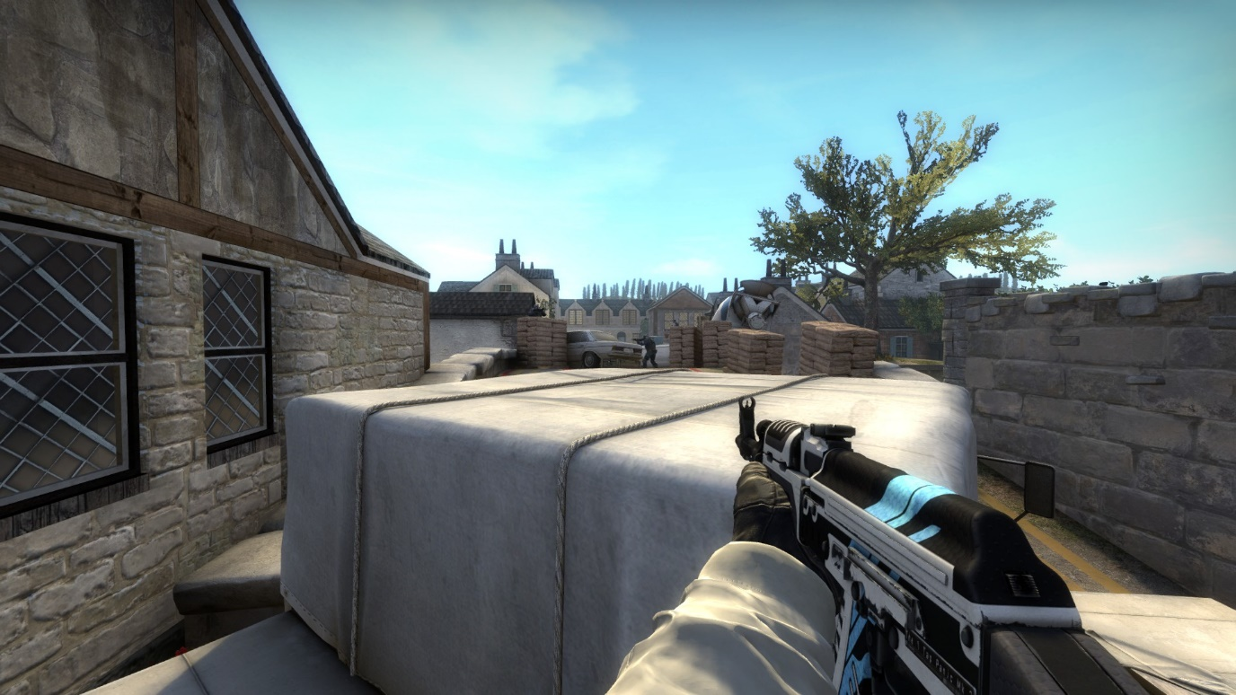
Offensive options available: 3
The Ts can peek either to the left, right or over the top of the truck. These all count as one offensive option due to how similar they are.
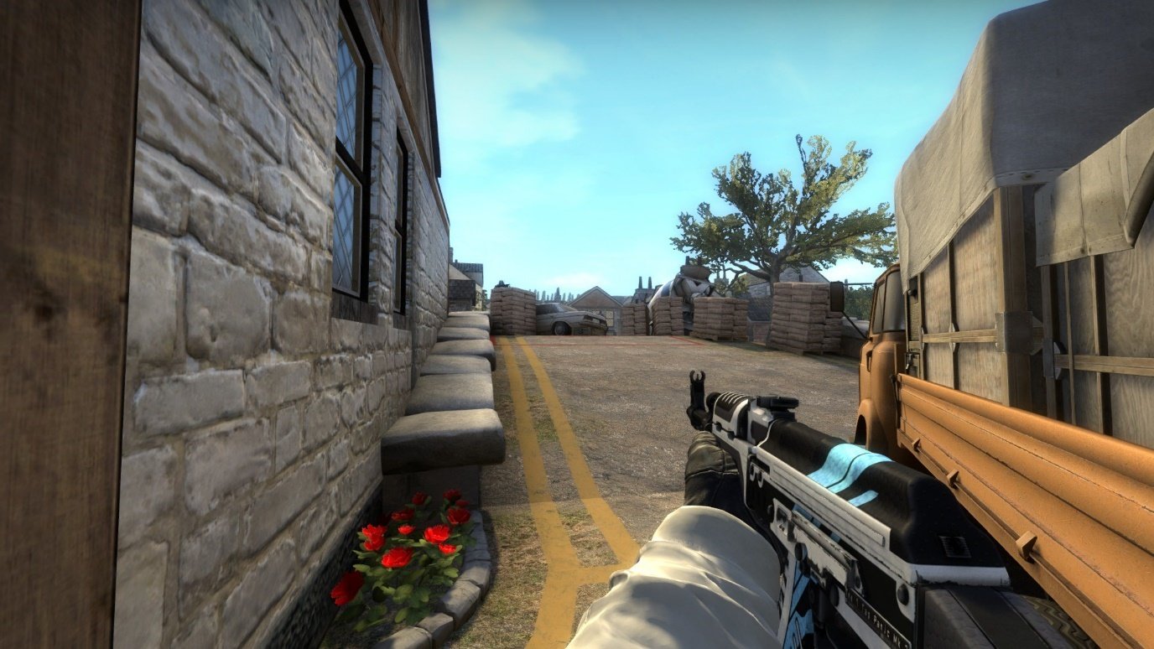
If they manage to kill the player on site or they just push slightly further. They gain one of their strongest positions on the bridge. This spot allows them to watch CT spawn from a similar headshot angle that is available to the CTs.
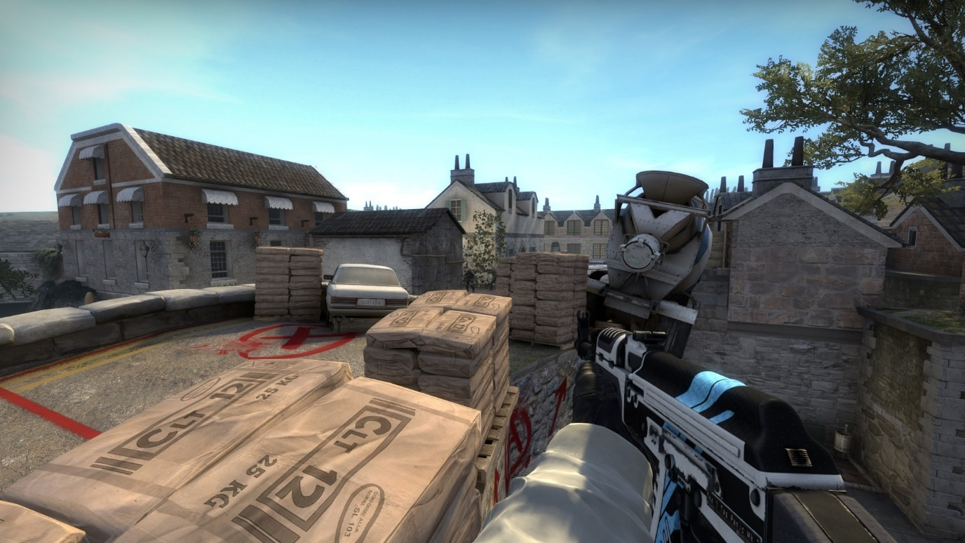
Defensive options available: 1
If the first player to peek the bridge gets a haircut faster than you anticipated, you can then fall back through T long. However, the length of the rotate and the exposed nature of T spawn makes recovery from this push a hard feat.
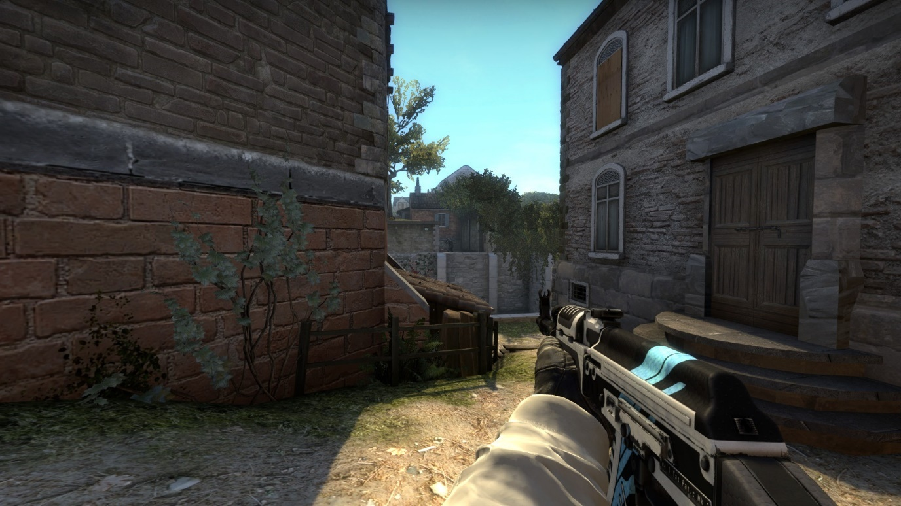

6. T Lower
Time taken to reach: 5 seconds
Possible enemy threats: 1
The only threat to the Ts at lower is the CT that pushes CT Stairs. It is how they choose to deal with the CT that changes how this area plays.
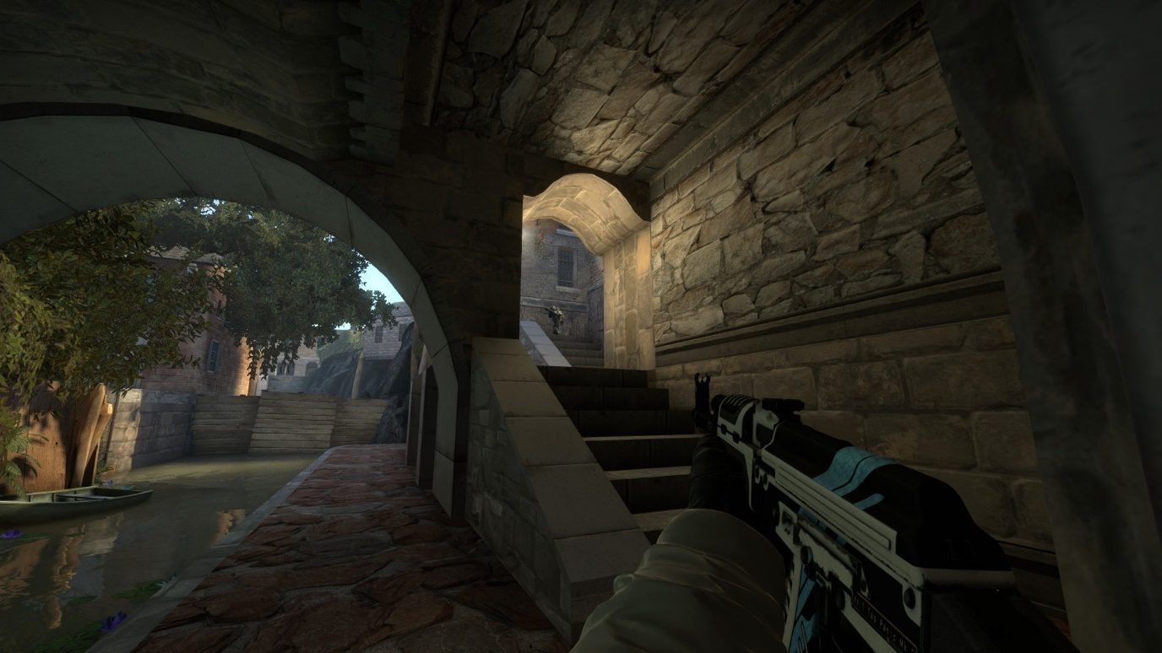
Offensive options available: 3
T lower is very dangerous to push as they see you before you see them thanks to them having the height advantage. If you can push this straight away, you are rewarded with a very direct route into the CT territory.
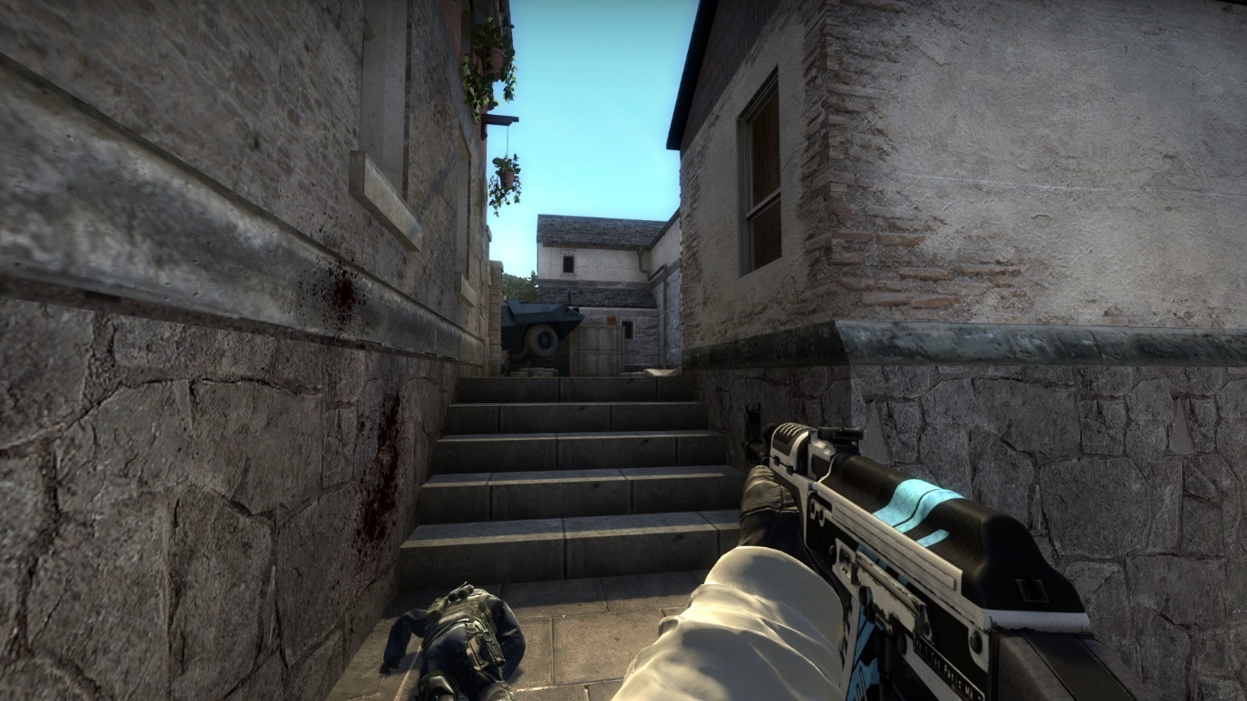
As listed before, CTs have several options available to them. But Ts also have counters to these. If you push the scaffolding, you can remain hidden from a CT hiding further back on the stairs. If a CT pushes you have the chance to kill them here. You also have a chance to react before they come face to face with you at the tunnel entrance.
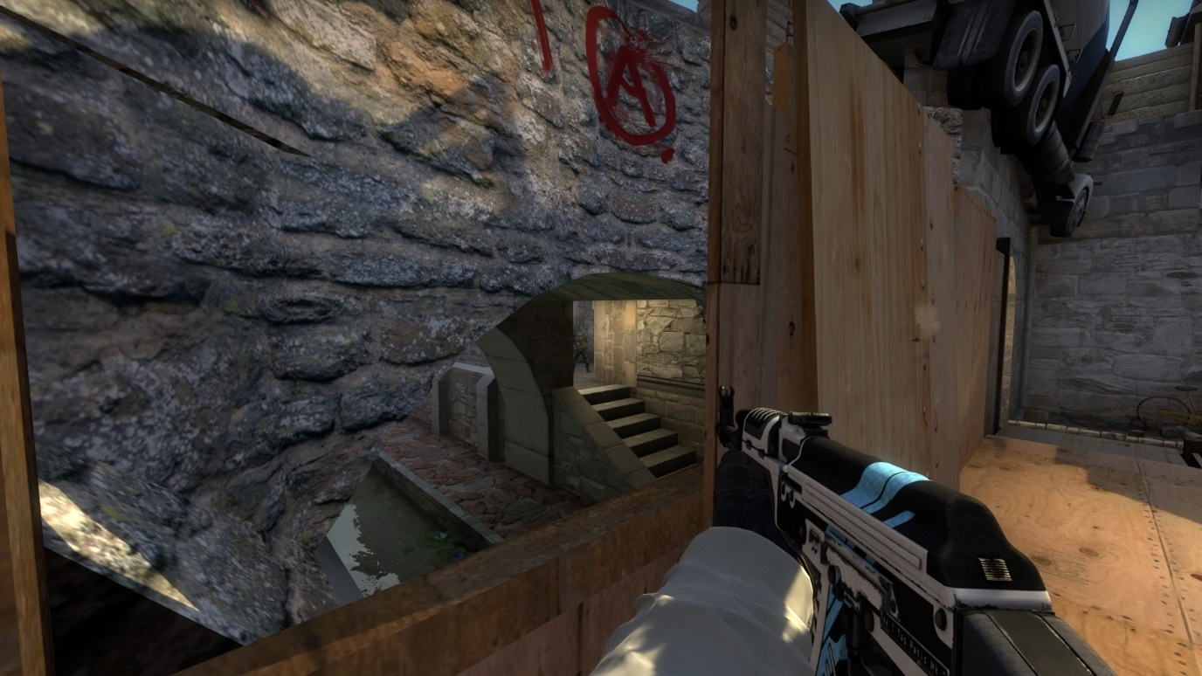
Using utility to control the tight tunnel the CT would be forced to rush through is the best way to deal with this threat.
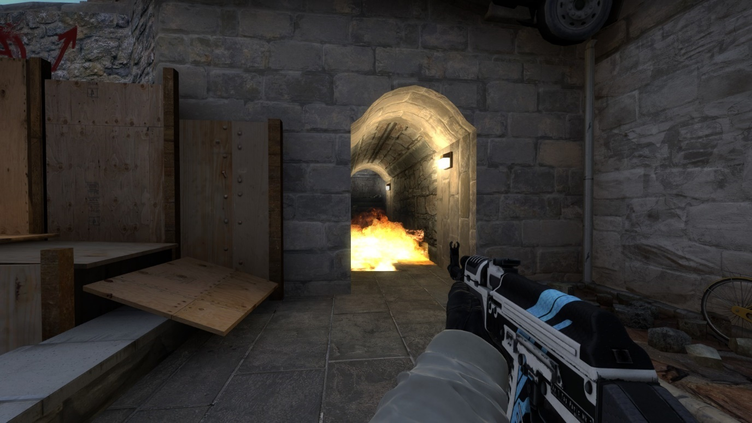

Finally, a T can push scaffolding and then jump down into T lower. This is slightly slower than the direct route but can be made more efficient with higher level knowledge of the movement mechanics.
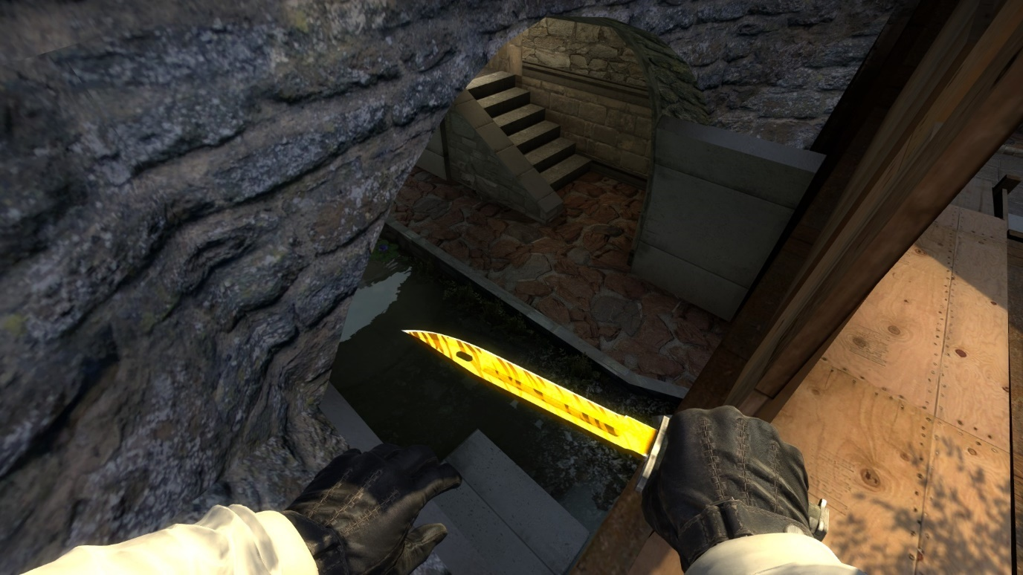
The drop down is great to surprise your opponent and doesn’t expose the lower half of you before you can see the enemy.
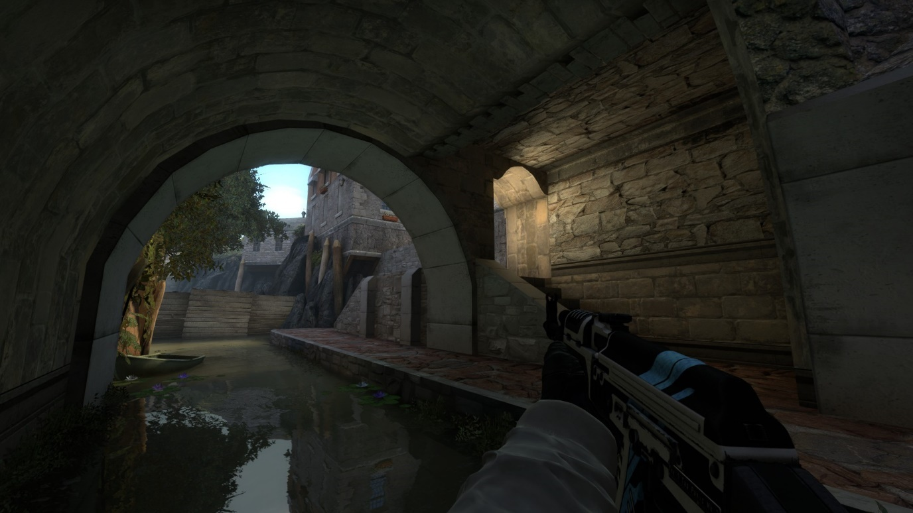

Defensive options available: 2
Rather than fighting any of these angles the T can instead choose to hold back closer to T long and wait for the push using the church overhang as cover. This allows them to watch for both tunnel and bridge aggression.
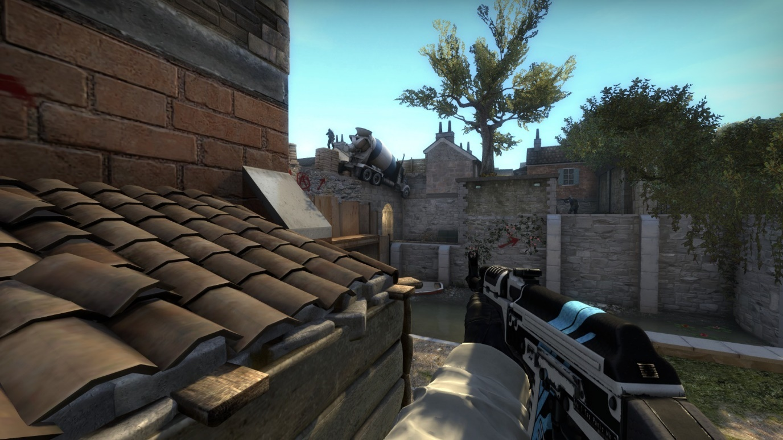
If wanting to get to T long without any hassle from CT stairs, they can smoke the tunnel and hug the right side of the staircase to avoid any bullets.
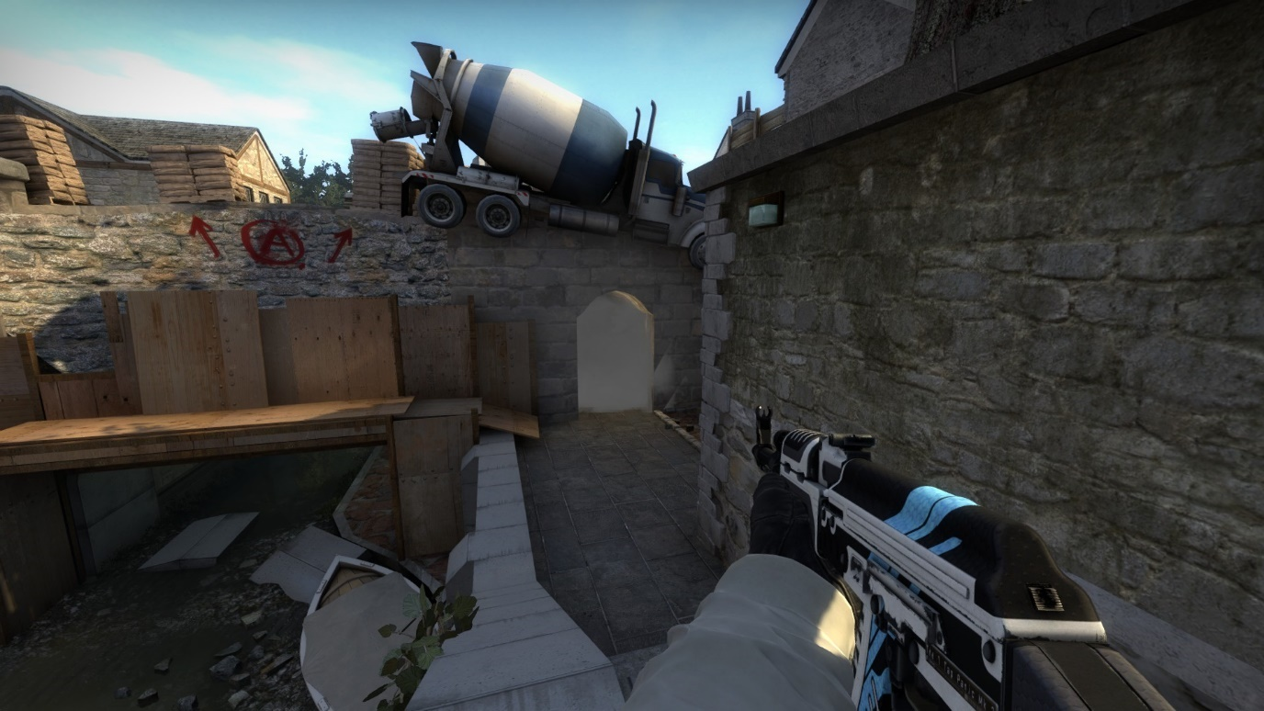

Bombsite Design

Plant Positions
Default: This spot if the easiest for terrorists to plant at but limits them to only be able to reliably see the bomb from the T bridge. It is hidden from any other position making it easier for CTs to narrow down where Ts might be defending from.
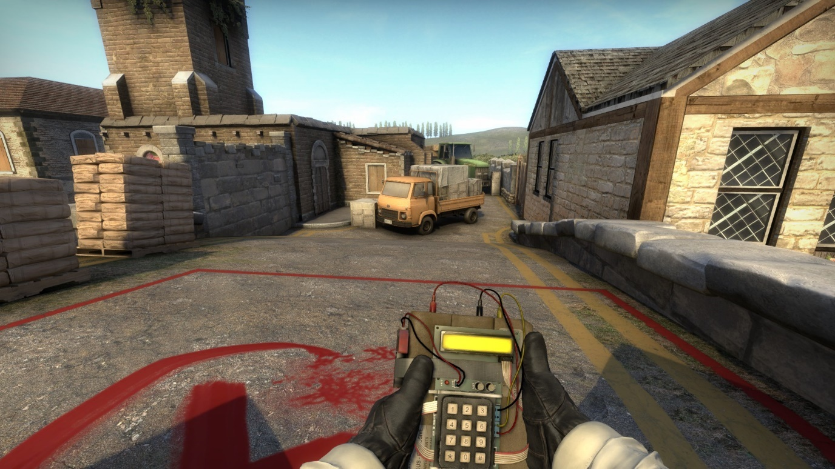
CT: This spot is rarely used as it is completely exposed from the CT side of the bridge, however if planted it offers the entirety of Ct as potential post plant positions.
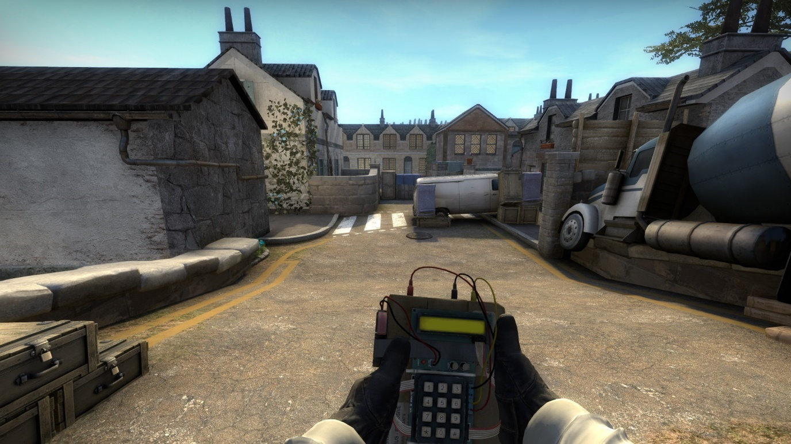
Mid Site: This spot is covered from CT long and Tree but allows for a narrow line of sight from both sides of the bridge making it much harder to both plant at and then retake from.
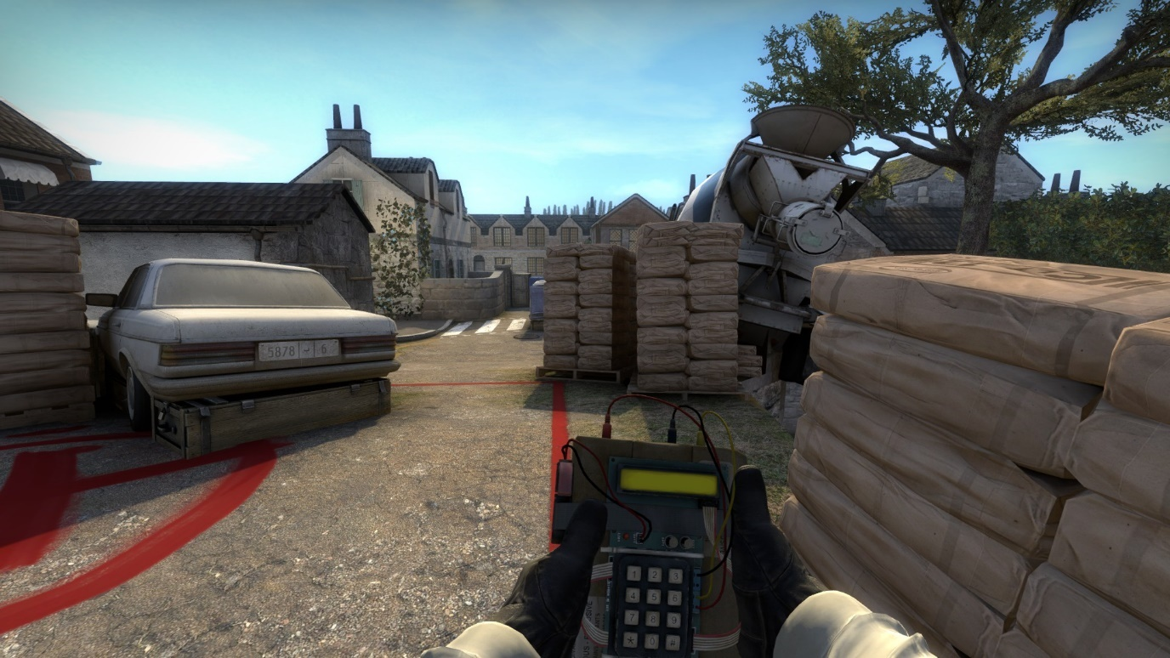

Post Plant Positions
Default: If planted default then Ts can hold it from T bridge. They cannot see it from their spawn so although the angle of defence is very narrow the T truck offers a strong defensive position with its multiple angles to peek from.
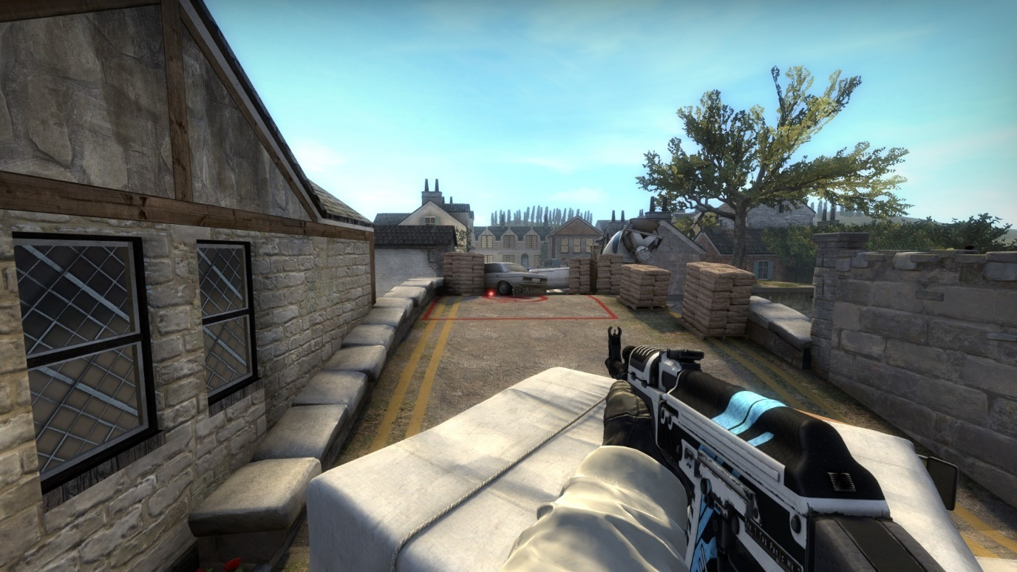

CT: If the bomb is planted on the CT side it can be covered from CT bridge, long and spawn. However, it cannot be seen from the T side of the bridge or the main section of the bombsite.
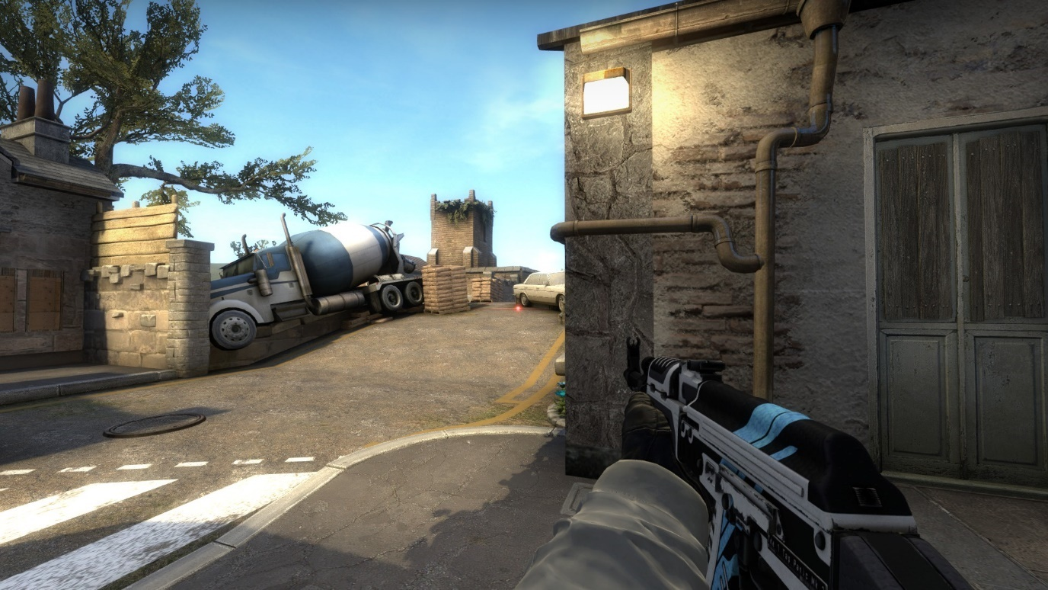
Mid Site: If the bomb is planted mid site then it can be seen from CT spawn and the T bridge. It cannot be seen by CT long and would require the T to peek into the open to cover it properly.
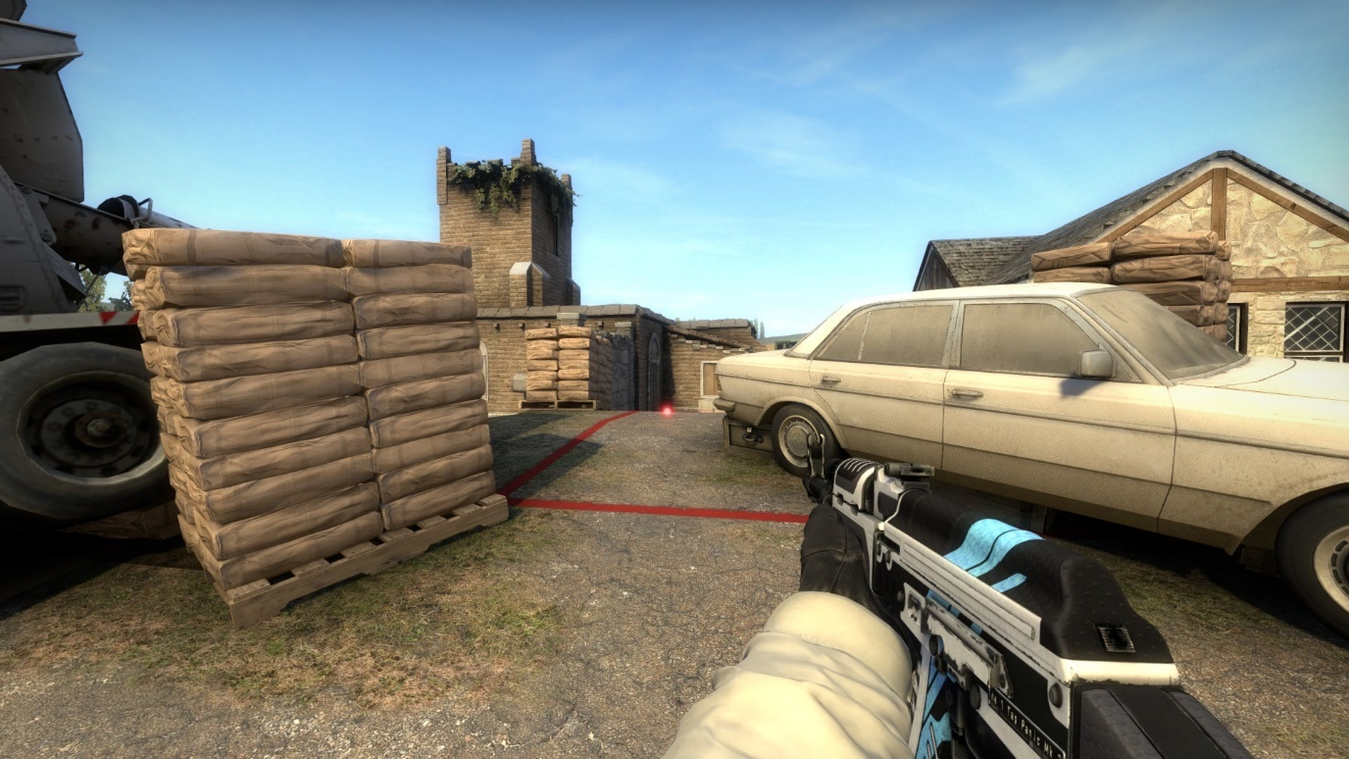

Map Detailing

Landmarks
Throughout my map I have created multiple landmarks that act to both orientate the player but also provide narrative theming and create a unique setting.
In T spawn I have the insertion point. Terrorists arrive in a truck posing to be a part of the construction effort on the bridge.
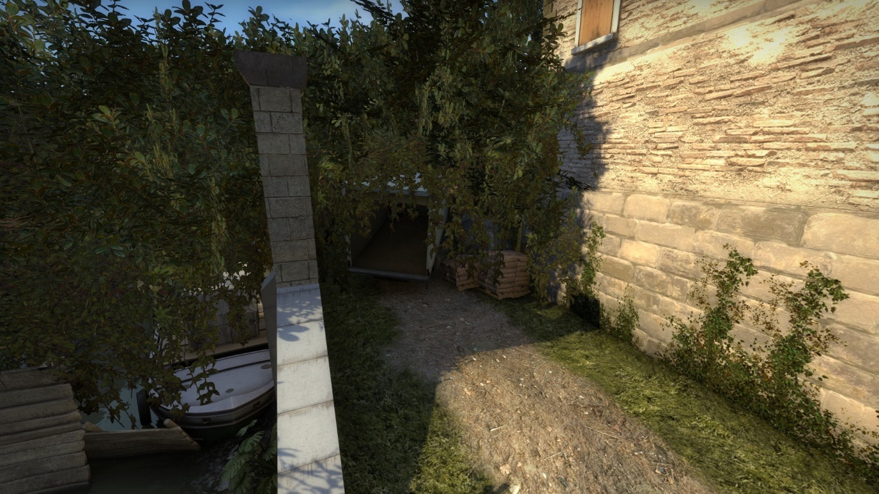
T long is structured around a derelict church. With ivy growing out of windows and up its walls, it acts as a nice contrast to the more structured and developed CT side.
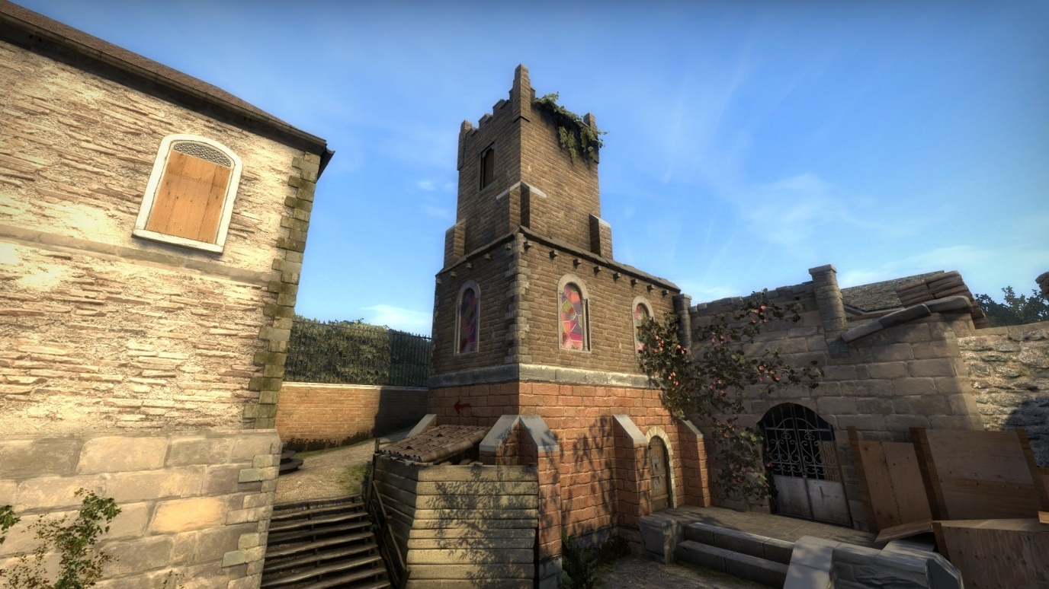
The bridge in the centre of the map. The T side is destroyed and crumbling away, while the CT side is still stable and well maintained.
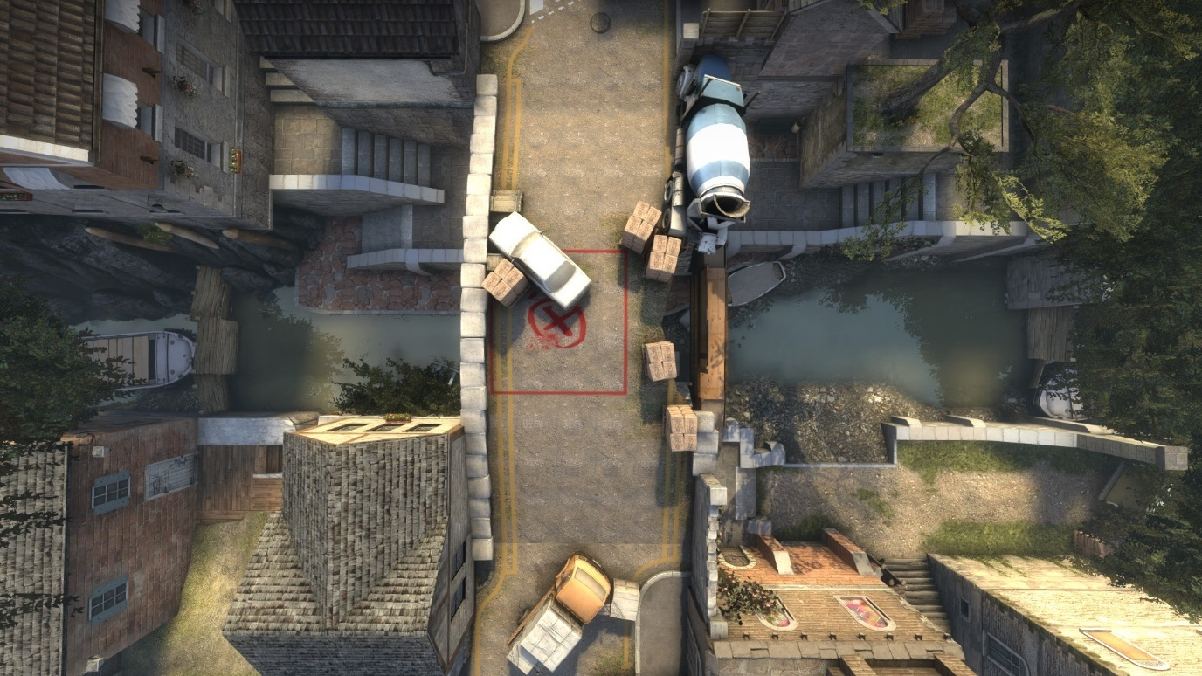
The canal is drained revealing the crumbling stone and dirty underbelly of the bridge.
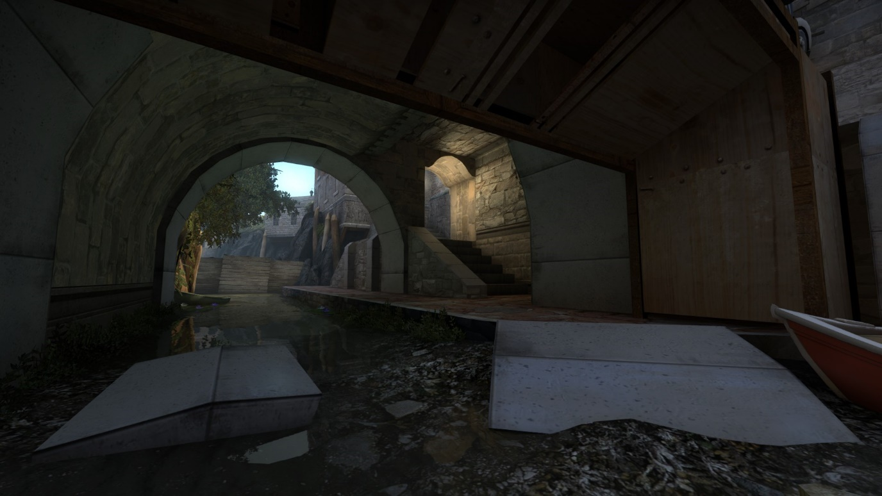

CT spawn has both CT house and the hotel. These are both more developed structured buildings; the hotel especially stands out as a larger than life example of a real-life building. Further exaggerating the differences between CT and T sides.
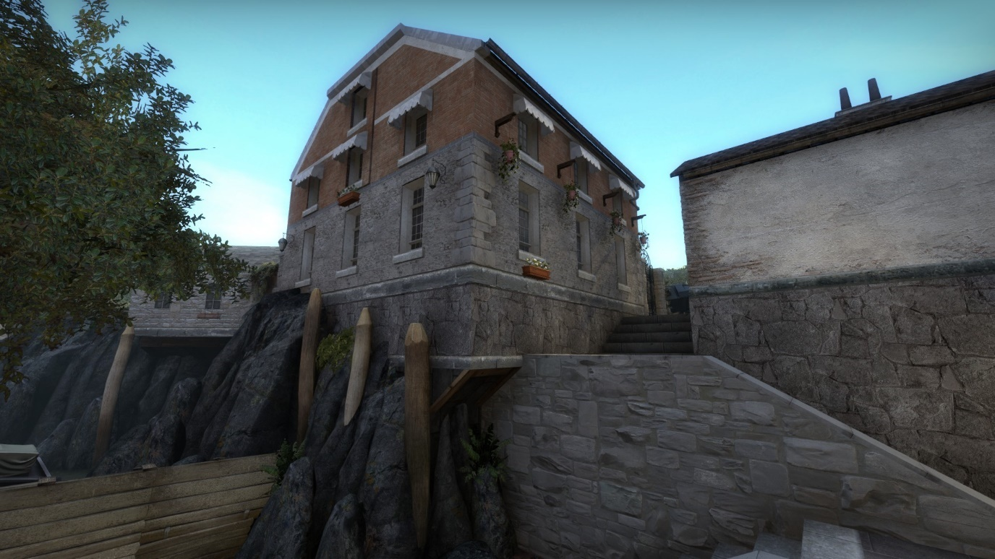
The CT houses at the end of the bridge break away into a more rural structured set of terraced houses.
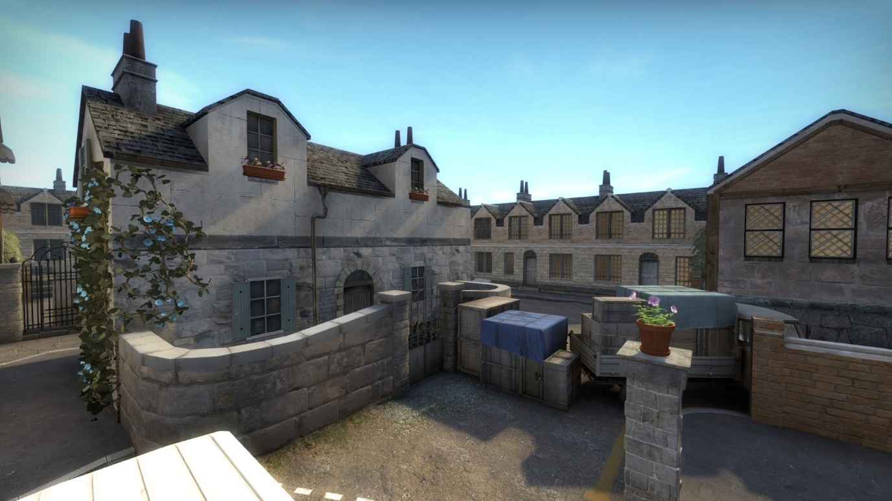

CT long acts as the connection between the grassy overgrown T side and the more clean, fortified CT side of the map.
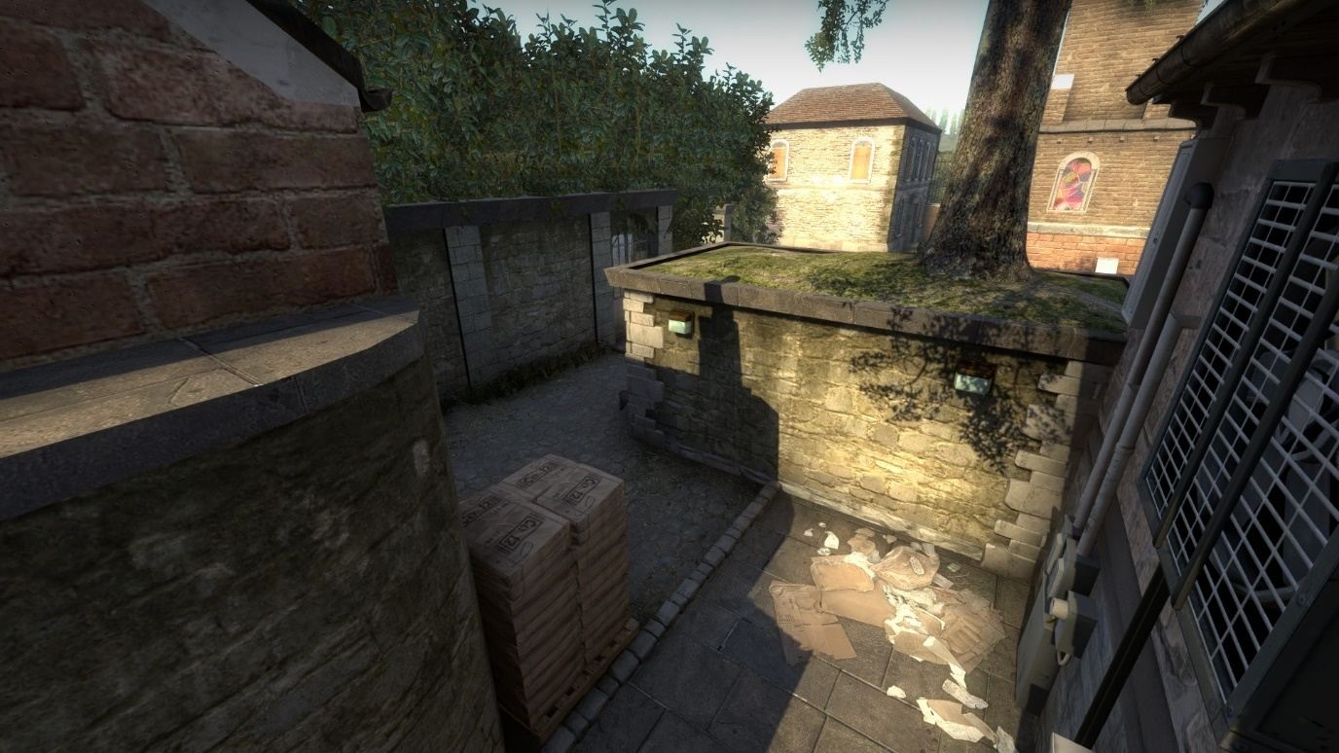

Colour Language
During the development of my blockout I used colour language to illustrate my intentions with the environment. Using a bright orange to direct attention towards to bridge and make it pop out of the environment and relay its importance.
The canal can clearly be seen using the base grass and water textures. Although not final they provide key information about the structure and sound ques that I wanted for these areas. Adding props like the small blue boat also help to add character to the area.
As you can see from the comparison image. The finished detailing kept most of these ideas and expanded upon others. I highlighted my key points of interest like the tunnel with brighter lights. The staircase was replaced by a sloped surface to flow better with gameplay and to help clear the path visually. The boat had its colour swapped to red to denote you were in the T side of the map, but its position largely remained unchanged throughout.
I used red and blue throughout my map to show team areas like the way older games used to. This isn’t seen as often anymore, to avoid it seeming too “Arcadey” I kept these subtle enough that they didn’t interfere with the gameplay.
CT Spawn
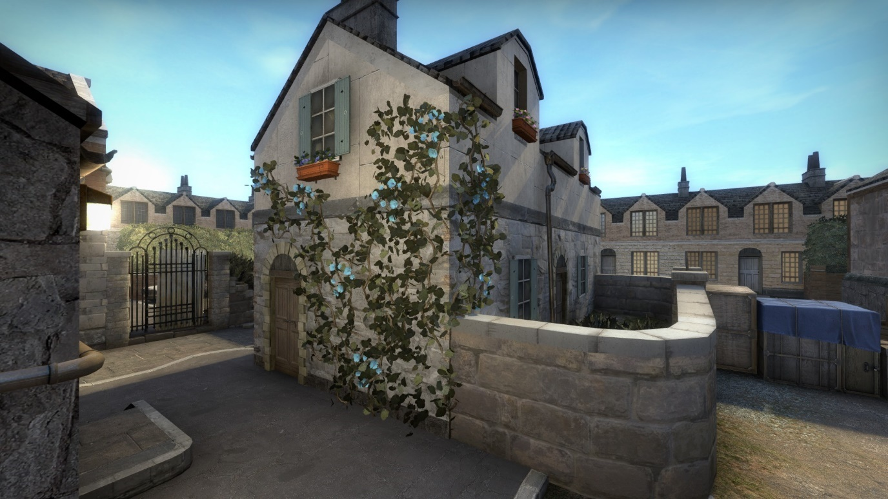

CT Bridge
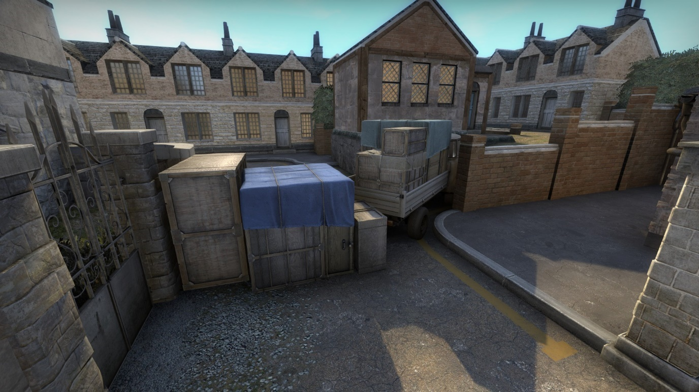
T Bridge
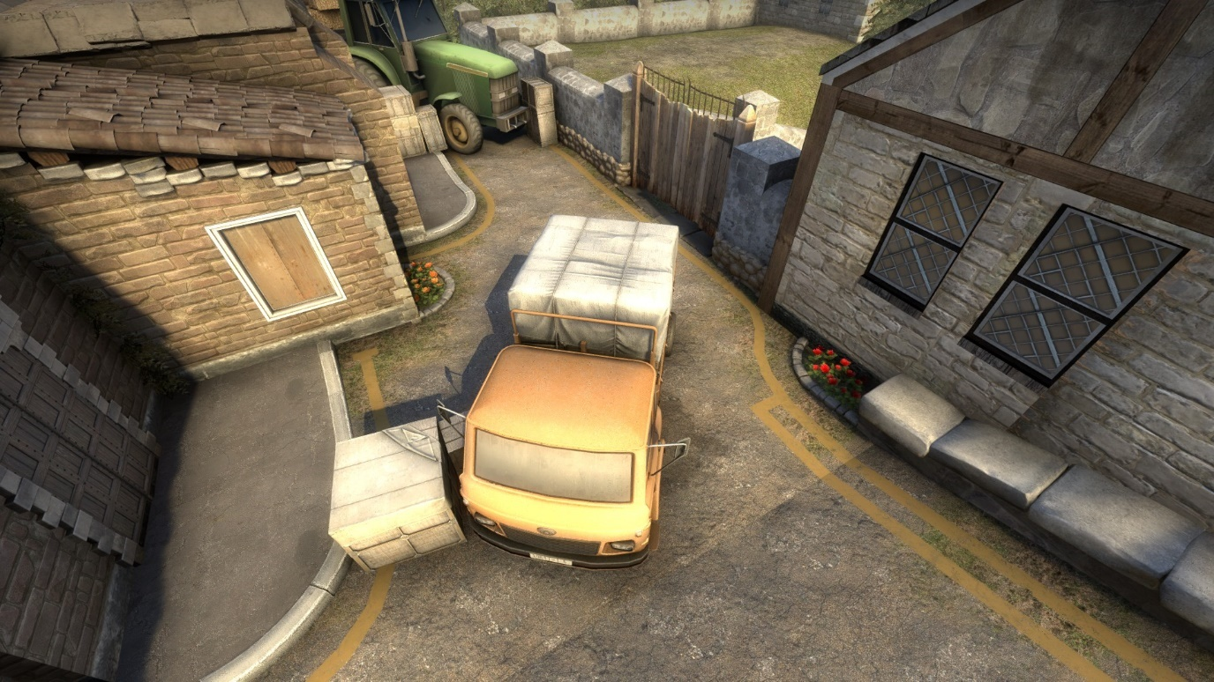

T spawn
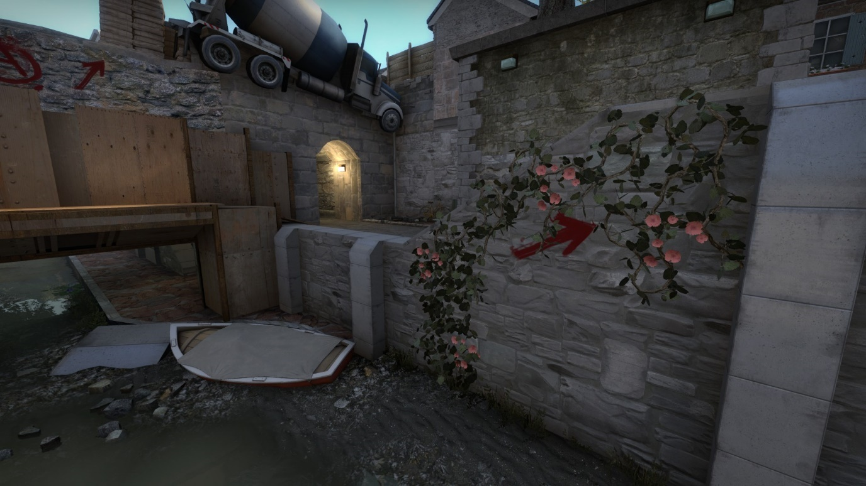
I tried to keep my textures within a very similar colour palette, changing the hue rather than the colour when necessary to accommodate colour blind players. I’m not entirely sure if I was successful throughout the entire environment as there are areas where the SAS models don’t entirely stand out.

Leading Lines and Breadcrumbs
The main area I can showcase as having this implemented is T spawn. This was the face of my map and was one of the first things players would see. I wanted the routes to be immediately apparent, unlike CT where the area is very straight forward, T spawn has many routes for the player to take in.
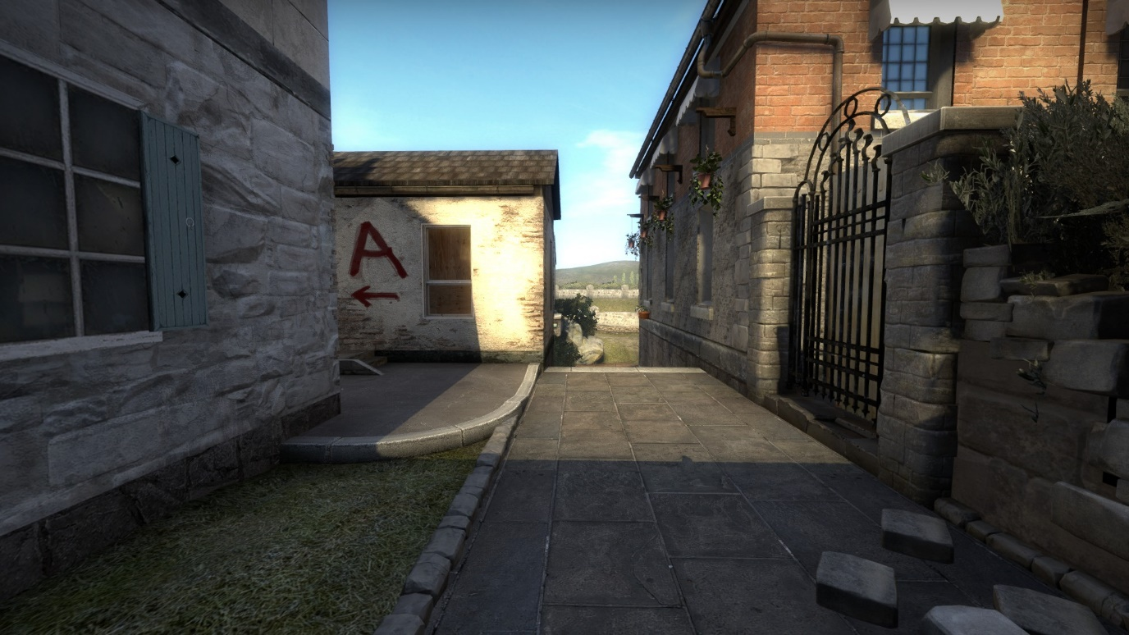
Once they learn the map the complexity of T spawn is a benefit as it allows for fast paced rounds. However, on first viewing it can seem overwhelming. I used these techniques to try and elevate this feeling.
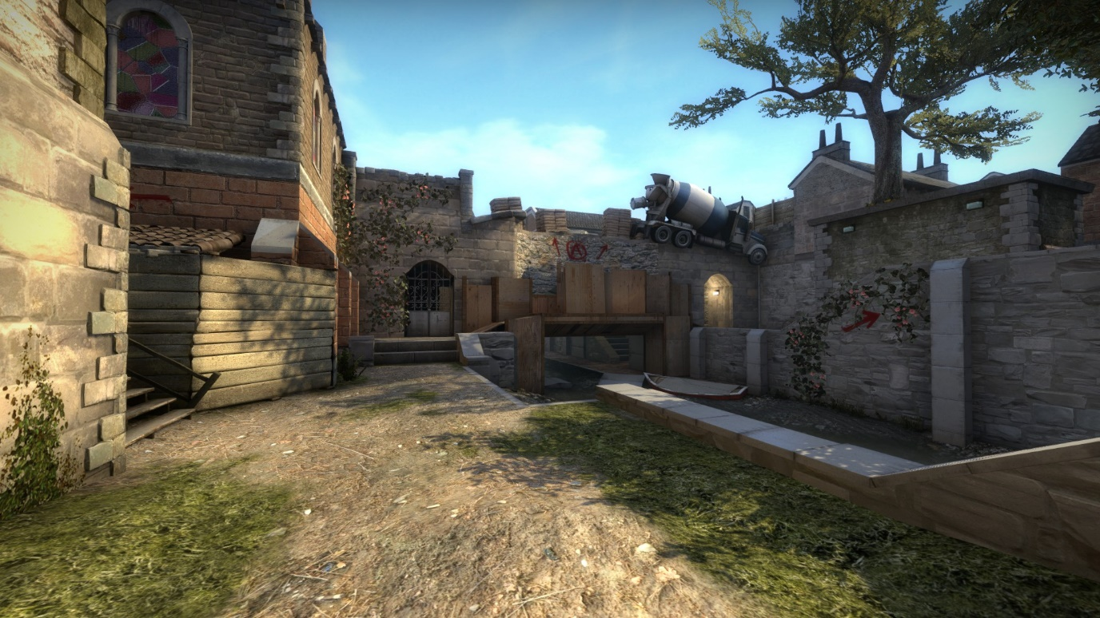

I have used prop orientation and displacement alphas to indicate the paths the player can take.
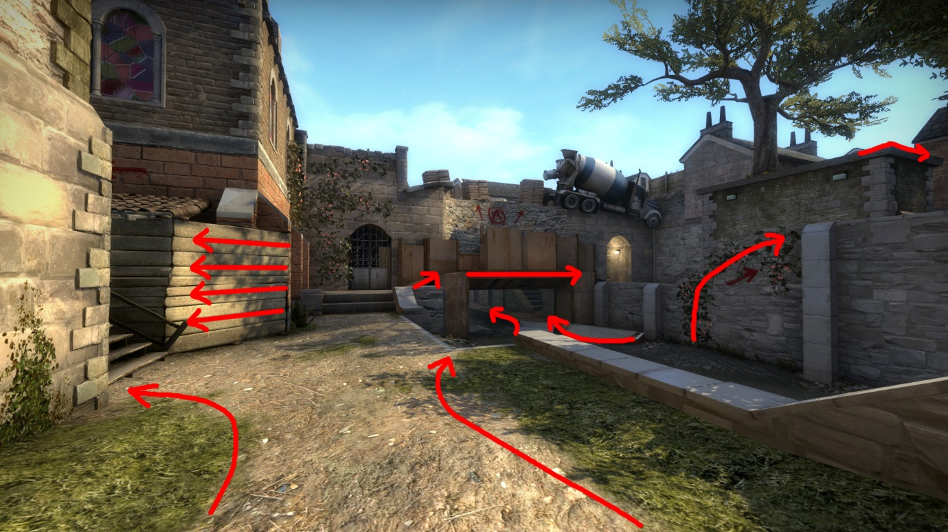
As for breadcrumbs, I have used pieces of the broken bridge to act as a walkway to better show the route under the bridge. I also added a brighter light to the tunnel to make it stand out, once you learn the map you realise how vital control of that area is but in earlier playtesting it wasn’t being noticed. These additions really helped draw attention under the bridge. As we know, openings attract attention and warrant exploration.
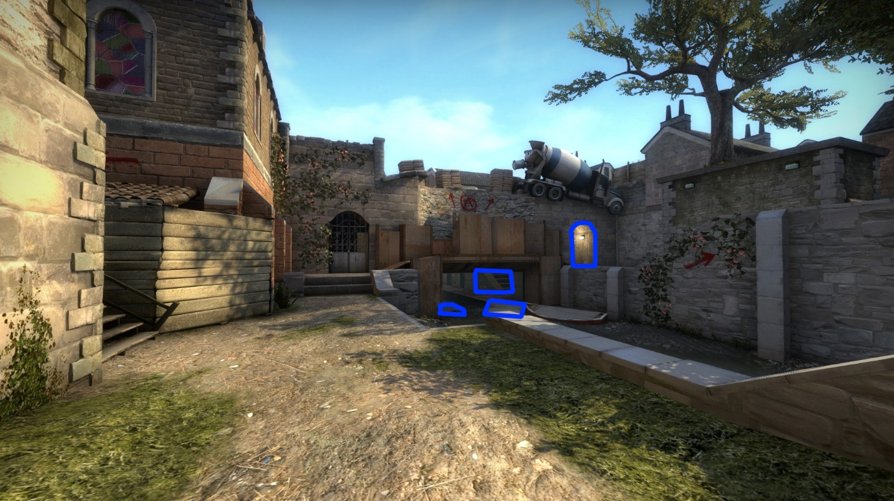

Pinching
The way I have structured my level has the attacking team constantly weaving their way around the outskirts of the level and then when they exit these outer passages they are looking at what I want them to see. I removed any extra corners or turns wherever I could try my best to simplify an initially confusing layout.

Below you can see the block out version I developed the detail stage from. This left image is the old layout for CT bridge. It worked but had far too many corners and wide angles for attacking terrorists to have to check. The newer simplified layout helps both navigation and gameplay tremendously.
